# A Smart Wifi System for a Multi Zone, Multi Floor Heating System

**By**

**Wolph42**

**Introduction**

Twelve years ago we (my wife and I) build our own house and during that phase we decided to go for floor heating everywhere! So no radiators, floor heating only. The decision was based on:

* its much more comfortable
* Its much more environmentally friendly (and thus cheaper as a bonus)
* Better control

The entire system that was installed covered: 4 floors with 2 zones on the 1st, 2nd and 4th floor and 4 zones on the 3rd floor (bedrooms and bathroom).

And so we entered the first year in our freshly build house with our comfortable floor heating system...or so we thought...

The first year turned out to be rather uncomfortably cold as the house temperature didn't go any higher than 17C during the winter and to top it of also resulted in a staggeringly high electric bill. Reason: and idiot of an installer. Solution: slowly becoming a floor heating expert. We're now 12 years further and I've just finished one of the biggest (probably THE biggest) 'do it yourself' projects of my life…

After the first year I started delving into floor heating systems with sensors, heating curves and whatnot. It turned out that the installer had put a heat sensor right next to the central heating (which was in an enclosed environment where it was typically 30C+) so the heating system was nearly always off (as it thought it had reached its target temperature)...AND he had set all the 4 pumps in the house to the maximum setting … 24/7 … all … year … long … It turned out that half our electrical bill of that year was: pumps!

Fixing this was relatively easy: lower pump settings and change the in-door sensor input (that is: turn it off). It still bugged me that the central heating only turned on or off based on the outside temp and the temperature of the return water. But it worked. For the next 10 years.

Eleven years later we had a cold winter once more, some floors were warm, some not, heating sometimes worked sometimes not and I was clueless as to what was going on. Everything 'appeared' to be working. Result after consulting some experts: broken thermostat of the central heating system and most zone valves of the floor heating units were stuck.

With the broken thermostat I once more started to delve into the world of floor heating and soon realised once more what a moronic system it actually was: if its cold outside it turns on; if its warm it turns off. It also turned out that the valves should regularly move else they get stuck and its very difficult to spot this issue (except that its cold). Consultant suggestion: install a 'smart' Honeywell system for the nice price of (at least) EUR 2000. This was the moment that I thought: then I'll do it myself…

Here an overview of all the steps I've taken to get to a working system, while writing this I realised that its hard to decide what to explain and what not. Stuff that I don't go into I will try to 'link' to an article explaining the topic. The core assumption I'm making here is that you know what an Arduino is! (in case you don't: <https://www.arduino.cc/en/Guide/Introduction>)

**Tools of the Trade (Required/Recommended Tools and 'Core' resources)**

Before we dive in I like to dive into this little topic first. When I started this I had *no* idea what on earth I would need down the road and since I didn't want to be in the middle of the flow of a project, only to find out that I was missing something (and then have to wait for weeks for it to arrive) I scoured the internet for advice and information on what you 'need' when starting with this. I got it pretty right from the start but there still were a couple of things I wished I had bought from the start, one of those is the 'extra hand' which I'll explain below. Anyway here a picture

of the tools you'll need:

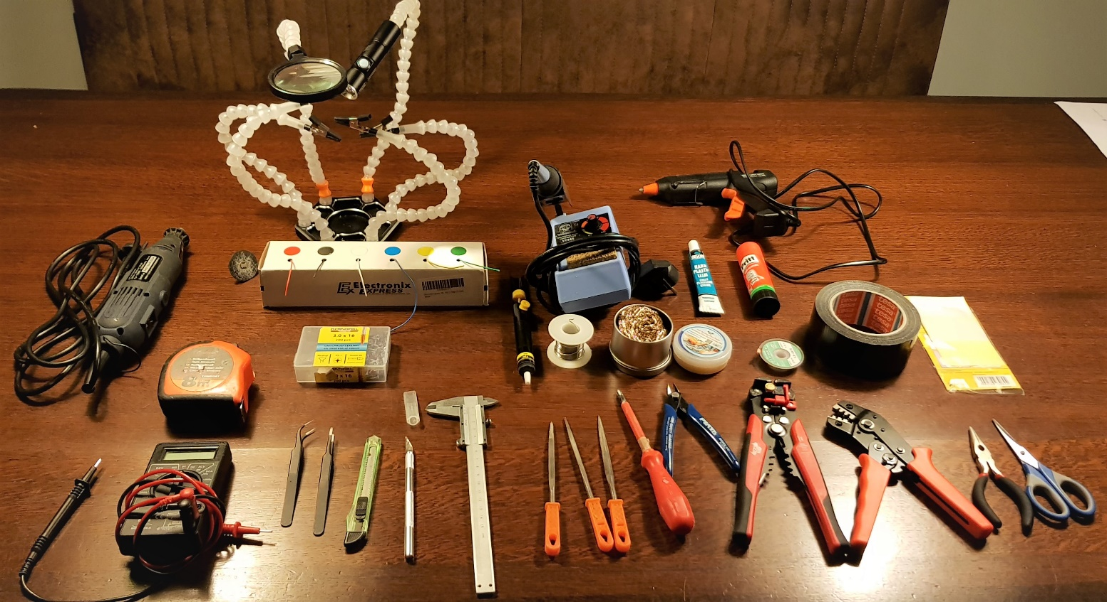

**From the top left**:

* A Dremel and a cutting blade (the small round thing next to it).
* The 'alien' device next to it is the advanced version of 'extra hands', which are literally 'extra hands' used to assist you with soldering. The loupe and USB flash light are nice add-ons.
* In front of that AWG 24 wires on a roll .
* **Right of that** all the gear for soldering:
  + A soldering iron (adjustable)
  + A solder 'sucker' (black tube with yellow knob)
  + Solder with flux core
  + Solder tip cleaner (right of the solder)
  + Solder flux (right again)
  + Solder remover wick (right again)
* **Top Right**: Assortment of sticky stuff:
  + Glue gun (with glue sticks)
  + General purpose glue
  + Pritt stift (used for 3D printing)
  + Duckt Tape
  + Sticky Labels (way to the right)
* **Back to the left** a tape measurer
* Screws (again for 3D printing casings) 3.0x16 mm
* **Bottom left**: a Fluke Multi meter (current, voltage, resistance, etc.)
* Assortment of tweezer, at least one flat and one pin
* Stanley Knife
* ZK20 aluminium knife
* A caliper (for precise measurements, again for 3D printing design)
* An assortment of fine files
* Assortment of screwdrivers (so more than just the one in the picture)
* A wire cutting tool
* An automatic wire stripping tool
* A crimping tool for AWG 24 size wires
* Assortment of pliers and finally
* A pair of scissors

As for 'resources':

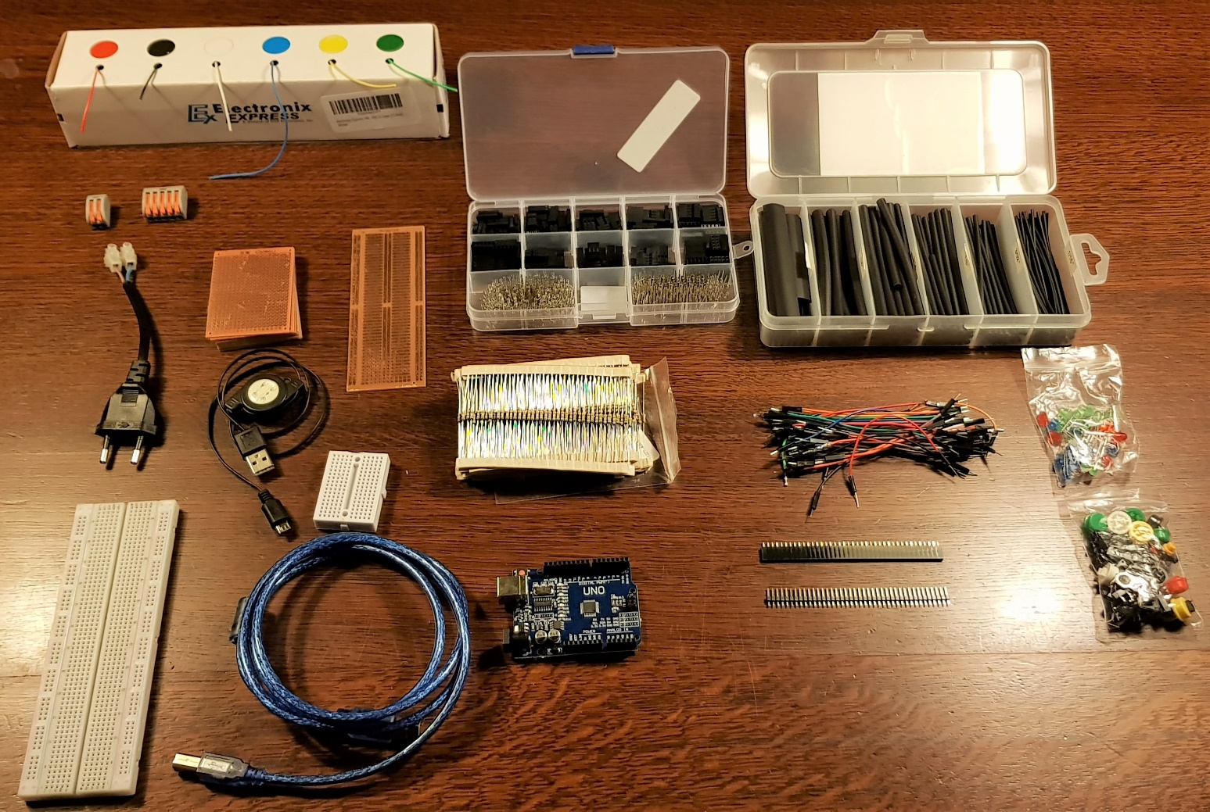

**Starting Top Left**:

* AWG 24 wires (I guess I already mentioned those…)
* In front of that: 'wago' wire terminals at least 2 and 5 levers (quite a few of them) and depending on your situation 8 + levers
* In front of those: a plug with wire connector
* PCB boards
* Right of those: a box with an assortment of Dupont Connectors
* And right again: a box with an assortment of of crimping tubes
* Left again: a micro USB cable (black) for the Wemos a USB B cable (blue) for the arduino
* Next to those cables: a long and short breadboard and an Arduino (for learning purposes)
* Above the Arduino: an assortment of Resistors (ranging from 10Ω - 10kΩ)
* Right of that: an assortment of Dupont cables (in the photo you only see male-male, but you'll need the other two types as well (male-female and female-female)
* Below those: a couple of strips of Female and Male pin headers
* And way to the right: an assortment of LED's and pushbuttons.

With all that stuff you'll have more than your basics covered! Ok lets dig in…

**Learning a new language (learn C++ programming language)**

Early on I decided that I was going to work with Arduino and Arduinos run on the C++ programming language. As an exercise I decided to set my 'end learning goal' on programming: Conway's game of life: <https://en.wikipedia.org/wiki/Conway%27s_Game_of_Life>. This took me a week and I was good to go! Note that I have created several programs in several programming languages for the past 3 decades. If you're completely new at programming it will most likely take you a lot longer than a week, but its still essential that you familiarize yourself with this as its an essential part.

**The circuit circus (learn to read and build circuits)**

This basically was a lot of googling Arduino projects to see what people did, how they did it and why they did it that way. It also gave me insight in the tools I needed to get started with this and the core 'resources' I needed (e.g. resistors) to not get stuck in the middle of a project. One project that I found during this stage which helped me a lot in the design of the project was this one: <https://create.arduino.cc/projecthub/erkr/multi-zone-heating-controller-41d40c> which is basically the same as I'm describing here but with an entirely different approach.

At the same time I delved into the world of international online web shops where you can buy stuff cheap. I initially came out at 'banggood' where I bought an 'Arduino starterkit' and some additional electronics like pushbuttons, led's and resistors. Later I switched to AliExpres and that's to date still my goto shop (for electronics).

**Making it do tricks (choosing the right device and programming it)**

The Arduino website really is the place to be for this part. First you download the IDE software: (<https://www.arduino.cc/en/Main/Software>) which is the interface between your pc (where you write your C++ code, compile it and upload it to the Arduino). Like most newbies I started with 'blink LED' Arduino tutorial: <https://www.arduino.cc/en/Tutorial/blink> to get a feel of what I'm getting into and to wet my toes in the cold water.

I actually wanted to create this project with Arduino, not quite entirely unlike the 'multi zone heating controller' Arduino project I linked earlier. However I didn't have internet (cable) access at most spots so I was forced to use a wifi module instead of an Arduino that and in that project you *still* need to buy Honeywell stuff, not so much of a DIY and a lot less control.

I've later learned that you have wifi 'shields' for Arduino so I *could* have gone for that as well but that would have been serious overkill. The point is is that most 'wifi modules' are powerful enough (calculation/processing power) to do that which I need them to do. Choosing the right one however was the real challenge. IF you start looking for 'Arduino Wifi Module' then the first thing that will pop-up is 'ESP8266'. And once you get to know that a bit you start seeing it everywhere. The ESP8266 is basically your go to Wifi-Powered-Arduino. Well that's not entirely correct more correctly: the ESP8266 is the Wifi-Powered-Atmega. Atmega is the 'chip' or core processing unit of the Arduino; just like the ESP8266 a core processing unit is. So what you're looking for is a 'board' with the ESP8266 on it. As usual: there are many. After some digging I ended up with the NodeMCU and the Wemos D1. I've read some comparison articles and ended up with the Wemos D1 mini, but NodeMCU would probably be fine as well.

Usually you have to use some interface unit to connect the Tx/Rx (transmission/Receiver) pins of the electronic board to your PC's USB port, the advantage of the Wemos D1 is that it has a micro USB port on board (yeah, finally something simple).

Getting it to do some 'tricks' however turned out to be yet another week filled with frustration, the IDE interface is relatively clean until you actually need to setup some libraries (these contain routines that for example make it a LOT easier to communicate with for example a sensor) and try to run your first compilation (this is the part where C++ code is turned into firmware which is uploaded to the Wemos unit), this was what I was looking at:

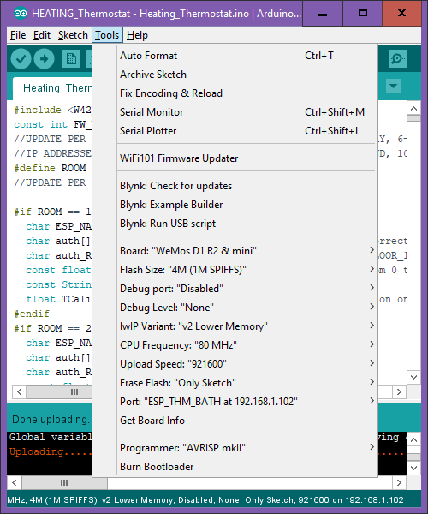

Yes those are all options and yes I was totally clueless which to choose...and choosing the wrong ones will result in some more 'head-bang-on-wall-bloodstains'. Hint: if you're using a Wemos d1, the screenshot shows the correct settings! Again lots of reading, posting on fora and trial and error got me to get it working. Note that 'port' here should initially point to the USB port ot which the Wemos is connected, which is 'COM3' in my case.

**Magic's in the air ('Over The Air' or OTA updates)**

Fairly soon after you have some different units running and are constantly disconnecting the USB cable from one and connecting it in the other...you realise that these units eventually will be all over the house, in ceiled box, behind a cover-up, inside a closet...if you ever need to do an update...my lord… fortunately there is something called OTA or FOTA which stands for '**F**irmware **O**ver **T**he **A**ir'. This turns out to be just adding a library, a python tool and a routine to your code and from then on your good to go: <http://arduino-esp8266.readthedocs.io/en/2.4.0-rc1/ota_updates/readme.html?highlight=ota#arduino-ide> The article behind this link gives you ALL the OTA options, I started out with the IDE version and later added the HTTP Webserver (but that's only possible after you've gone through the Raspberry pi section).

**What do I actually want? (The design phase)**

So by now I'd settled for the Wemos D1 a 'controller', but with only the controller you're not gonna concur the world, you need the 'peripherals', these are: a power supply, some buttons, a screen and of course a temperature sensor. I eventually ended up with this schematic:

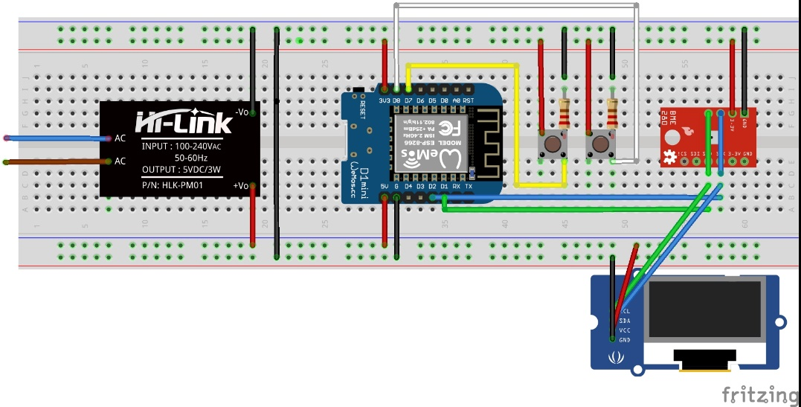

*Note that the OLED display was actually a Wemos shield (see photo's later).*

What are these:

* A Wemos D1 mini
* A 5V AC-DC step down convertor
* 2 push buttons
* 2 10kΩ resistors
* A BME280 sensor
* A 64x48 I2C OLED Wemos shield* (SSD1306 chip)

*A 'shield' is a piece of electronics (in this case an OLED screen) that you can easily 'attach' to the core board (in this case the Wemos D1).

To get this running took me roughly 2 weeks and quite some metaphorical blood stains on the wall painted with my head, fuelled with frustration. Most important **learning moment**: the pins on an Arduino (with which I started) do NOT coincide with the pins on a Wemos D1. E.g. Wemos pin D1 = GPIO 5 on an Arduino. Here you can find a full description of the (p)infrastructure: <https://escapequotes.net/esp8266-wemos-d1-mini-pins-and-diagram/>

So if you, as I initially did, simply connect your peripherals on the Wemos to the same pin numbers as you did on the Arduino...some weird sh#t will go down and it drives you bonkers not understanding why.it.won't.work!

**The Electronic Highway (Mapping the overall infrastructure)**

Now that I had a running ESP, an interface and a working sensor, it was time to start thinking of the infrastructure in my house and what I needed in total. Which resulted in this 'Heating infrastructure chart':

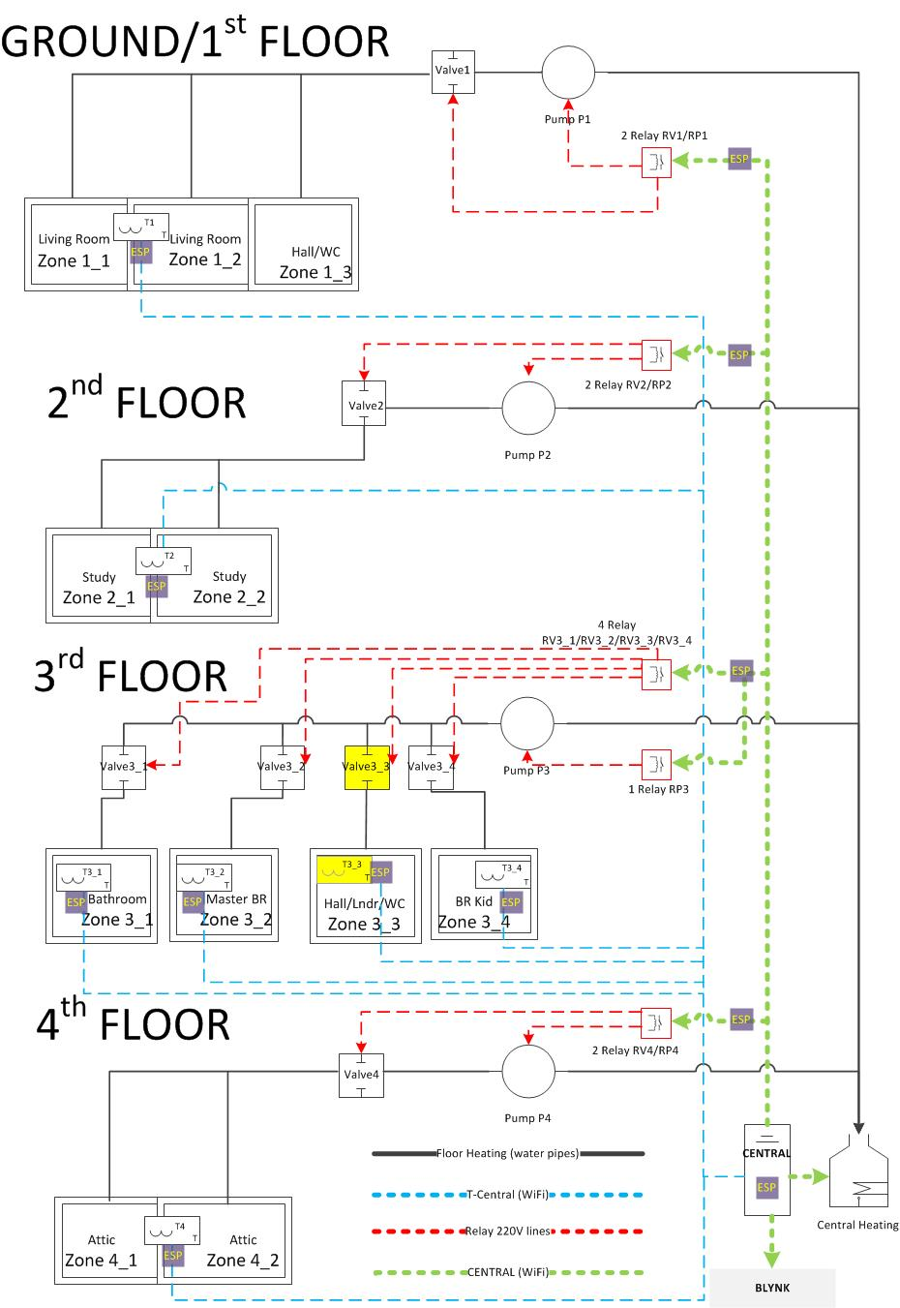

This gives an overview of the 'heating' infrastructure of my house. There's a distribution unit (more on this later) on every floor consisting out of 2 or 4 zones, together with one ore more valves and one pump per floor. Furthermore:

* Solid lines: lines/pipes are already there
* Dotted lines: the DIY part.
* The yellow marked part was a zone that was not attached to a thermostat and didn't have a valve (yet).
* ESP: the wemos D1 wifi units
* Blynk: I'll get to that later!

This chart should have given me some hint of what on earth I was getting into...but for now I remained blissfully ignorant...

**ET Phone Home (Choosing the interface software)**

By now roughly one month had passed during which I had already decided that it would not be wise to build an interface from scratch as there are many tools/platforms out there on which you can build one… and there free! (well, mostly). I also decided that I want to 'interface' from my mobile phone. But which platform to use…? With googling I found several interesting 'interface providers' like:

* Home Assistant
* Node-red
* Cayenne
* Blynk and
* Openhab

There are (many) more, but these seemed the most promising and most referenced. To make my final choice I employed a 'search result google' trick: using several search routines like 'Home Assistant' and 'Home Assistant ESP8266' and 'Home Assistant Arduino' and counting the number of resulting hits. The most consistent and promising search parameter was with 'esp8266' which rendered the following search hit results:

|  |  |
| --- | --- |
| esp8266 ("node-red" OR nodered) | 101k |
| esp8266 "home assistant" | 257k |
| esp8266 "cayenne" | 293k |
| esp8266 "blynk" | 809k |
| esp8266 "openhab" | 103k |

What does this tell me? That the most online activity takes place with 'Blynk'. And this means a strong user base! And that is **the most vital parameter** when choosing this kind of software when you're a newbie like me. So Blynk it was! <https://www.blynk.cc/>

**My first Blynk (getting to know Blynk)**

Currently I'm an 'active' participant on the forum and helping out others with beginners problem, but I can't say that I now grasp the full potential of Blynk. It is *that* versatile and it is *that* good. And as expected the forum is VERY active, questions are usually answered within the hour. In contradiction to e.g. this post: <https://www.esp8266.com/viewtopic.php?f=160&t=17320&p=74858#p74858> which resulted in a discussion with the moderator or this one: <http://forum.arduino.cc/index.php?topic=536165.0> which didn't get any reply.

First step (after setting up an account and downloading the library) was building the 'hello world' among the electronics circuits: a LED operated (on/off) from my phone. This I got working within a couple of hours, so far so good! Next step was interfacing with my DIY thermostat which took me a couple of days and some (by now familiar) frustration.

As it turns out, Blynk is a 'paid' cloud solution. 'Paid' as its initially free and if you don't do anything funky it will remain free. I however *did* want to go 'funky'. How does their earning model work?: Blynk consists out of 'widgets' like a button widget, a led widget or a 'value display' widget with which you can build the interface you want. Super easy to build and setup. However the widgets cost 'energy' and 'energy' costs money. You start however with 2000 credits of fee energy AND (this I can really appreciate) energy 'recycles'. So removing the widget will return the energy. What I ended up building however is close to 30,000 energy (~EUR 30,-), which in itself is not that bad for a good app, however its still a **cloud** solution. Queue the really 'Blynk' good part: you can install Blynk on a local server which is fully supported and fully free!! Guess what my next step is going to be…

**Welcome to the sweet world of the Raspberry Pi (Setting up a server)**

This is one of those things where I'm in doubt whether I should go into detail or not, now because I basically only followed online tutorials and hardly did anything myself I don't see the merit in copy pasting others' work in this article, so here's the short version: another month with a 'steep learning curve', a lot of googling, reading, trial on error, etc. which finally ended up with:

* A running raspberry pi: <https://www.raspberrypi.org/documentation/setup/> , with:
* A java and Blynk server, with mail enabled: <https://github.com/blynkkk/blynk-server/blob/master/README.md#quick-local-server-setup>

And

<https://diyprojects.io/blynk-how-to-install-a-private-local-server-on-raspberry-pi-3-unlimited-energy-test-wemos-dht22/>

* A java server that *actually* runs on startup (after e.g. reboot) after lots of digging, this worked for me:

Run command:

*crontab -e*

add line:

*@reboot java -jar /home/pi/blynk/server-blynk-java8.jar -dataFolder /home/pi/blynk &*

* A web server (why I'll explain later, you did got a hint earlier though: <https://maker.pro/projects/raspberry-pi/raspberry-pi-web-server>
* A Samba (file) server (same reason as the web server): <https://eltechs.com/raspberry-pi-nas-guide/>
* A router with the correct Blynk port (9443) on the RPI forwarded to the outside world: <https://www.wikihow.com/Set-Up-Port-Forwarding-on-a-Router>
* A NOIP URL directed to my local server: <https://www.noip.com/>

**Getting Served (OTA over a file server)**

With all of the servers and services setup on the RPI, a HTTP-type firmware update is now finally possible. As I've mentioned and linked earlier; NOW you can setup OTA through a file server: <http://esp8266.github.io/Arduino/versions/2.0.0/doc/ota_updates/ota_updates.html#http-server>

What I added to the mix was adding an extra access link on the samba server to the location: /var/www/ on the RPI and added that as network drive to my PC. This allowed me to swiftly copy firmware updates to the webserver and letting the devices update from there. This process is not fully described in the link. What you additionally need to so is:

Run this terminal command on the RPI:

*sudo leafpad /etc/samba/smb.conf*

And then add the below to the file:

*[www]*

*comment = www*

*path = /var/www/html/*

*browseable = yes*

*writeable = Yes*

*create mask = 0777*

*directory mask = 0777*

*browseable = Yes*

*public = yes*

The earlier "setting up NAS" link tells you how to create a network drive to that location. What I did next is in the directory where the firmware ends up (which is the directory where your "xxxx.ino" = C++ code is stored), is to add a file called:

Rename_to_THM_1_Living.bat

With the following content:

*del x:\fota\ESP_THM_LIVING.bin*

*rename Heating_Thermostat.ino.d1_mini.bin ESP_THM_LIVING.bin*

*move ESP_THM_LIVING.bin x:\fota*

Where

**"Heating_Thermostat.ino.d1_mini.bin"** is the generated firmware by the IDE

**"ESP_THM_LIVING.bin"** is the file ending up on the server (so the unit can find the correct firmware).

**"x:\fota"** is the network drive pointing to the webserver: /var/www/html/fota

So the bat: deletes any file still left on the server; renames the IDE firmware output to a new name that belongs to the unit in question and then copies it to the server.

In the Blynk app I have a button 'look for updates' which when I turned it on the unit looks for 'his' firmware, pulls it off the server, installs it and turns the 'look for updates' off (and updates the version number). This works much faster and is more reliable than the classic OTA I initially described and used.

**Its getting hot in here (The Heating Sytem Explained)**

Next to the thermostat that is going to tell me how hot/cold it is, it also needs to tell my heating system to do something and in order for my heating system to 'do' something I need another controller and a relay unit.

But before we go into that let me first introduce you a bit more in the wondrous world of floor-heating. Floor heating (like 'normal' heating) is actually really really simple...even though the units that are involved can look rather intimidating:

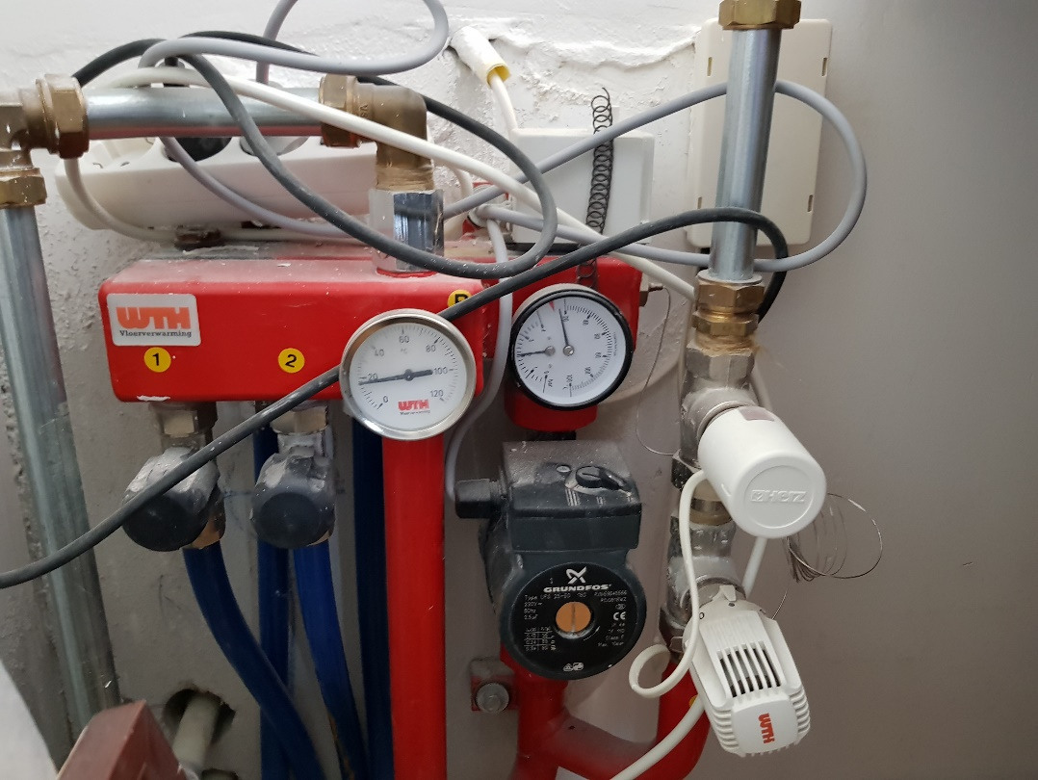

And this only 2 zones with 1 valve!

So what are we looking at? The warm water enters the system trough the pipe at the right.

The first thing the warm water encounters is a valve (the white thing with 'Herz' on it). The official name is 'Thermostatic actuator or Thermal actuator'. This valve is turned on (=open) or off (=closed) by a relay. This valve is a 'normally closed' valve meaning that if there is no current running: its closed. What is tricky about these things is that it takes 3-5 **minutes** for them to switch state. When I first encountered heating issues I checked whether these were working and concluded that they didn't as they didn't 'move' when the relay was on/off...little did I know. After some googling (which was far more difficult to find something than I anticipated) I found out how they worked (220V and 1-3W power will slowly heat up an element inside the actuator witch forces the state change). Here a picture of the valve **closed**:

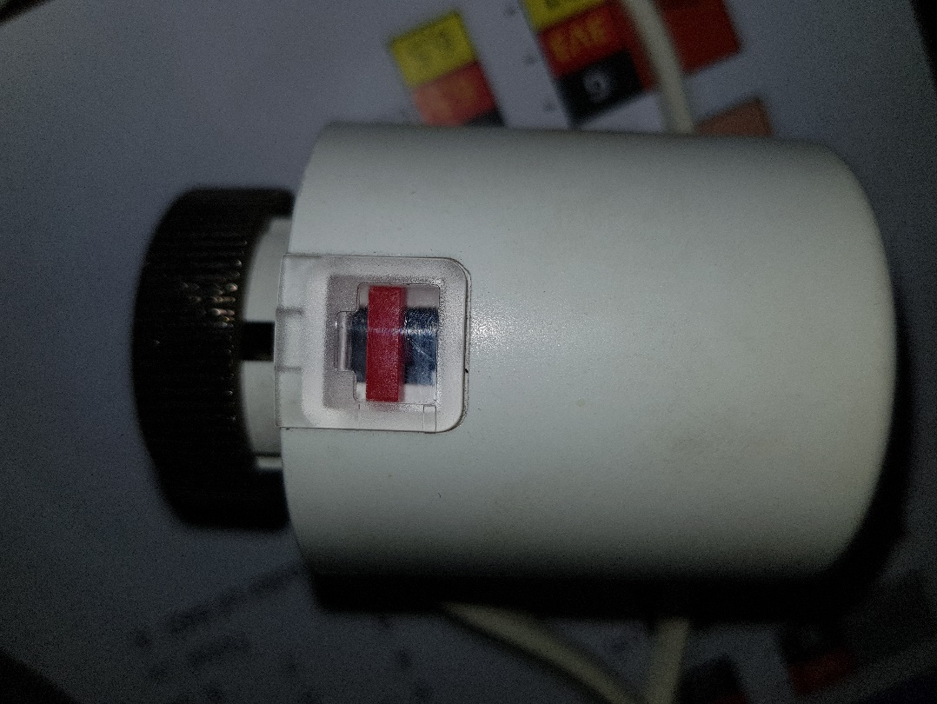

and **open**:

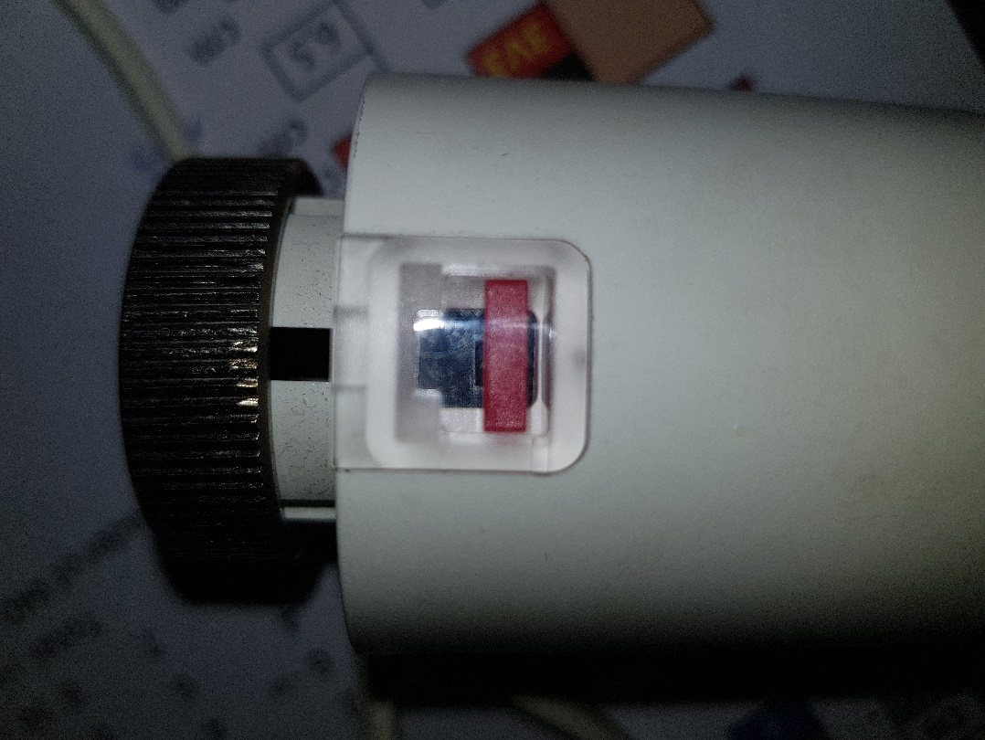

The second thing the water encounters is yet another valve, this one is probably more familiar to most as it’s a 'thermostic valve'. This thing nearly does the same as the thermostatic actuator, but then with more control. It will close when the water gets too hot and will only let a very limited amount through. For wooden floors this should never exceed 30C.

The third thing the water encounters is the pump, that’s the black thing with 'grundfos' on it. On top you see a switch which can be set to I,II or III which is how 'hard' it will pump. My dear installer with which this all started had set it to III which is the equivalent of 85W.

The fourth thing the water encounters is the distribution unit, that’s the red apparatus with the tubes coming out of it. All this does is divide the water over the different 'zones'. Modern version have special 'flow limiters' on them to influence the water flow per zone, mine is more simple; water comes in on one end and goes out on the other, with the law of least resistance leading!

The fourth thing the water encounter are the black knobs and the blue tubes. The knobs don't do anything (allows you to manually close off the system should you need to) the tubes go into/under the floor (where the actual heating takes place) and return at the back of the distribution unit. From thereon it flows back to the central heating system where it gets heated again (so yes: it’s a **closed** system). Note that each tube goes into a 'zone'. So this particular unit has physically two zones but only **one valve** so its effectively acting as one zone. Here's a unit where the valves are directly controlling the zones;

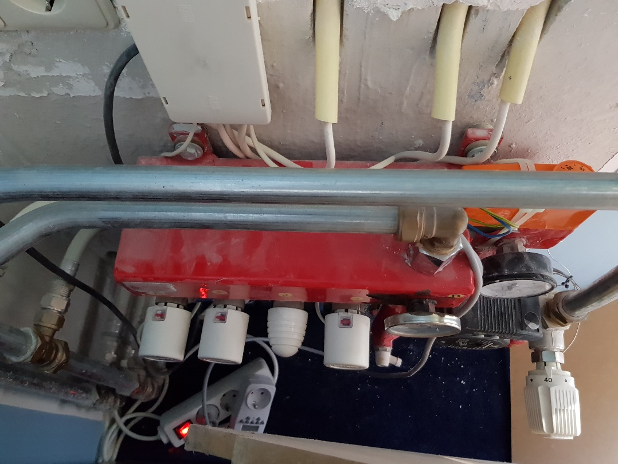

As you can see the actuators have moved from the main pipe directly to the zones. Note that the 'egg shaped' knob is the same as the black knobs: always open. In the above schematics this is one of the yellow marked areas: a zone for which I had to install a valve.

Now that you know this you understand that to control the heat in one 'zone' you need to control at least the valve for that zone and preferably also the pump for that distributor so its not running 24/7. This is done with relays.

What you might not yet know is that both the pump and the valve need to work occasionally or they get stuck. Queue the maintenance cycle, but first:

**Relaying units (relays)**

This is a relay:

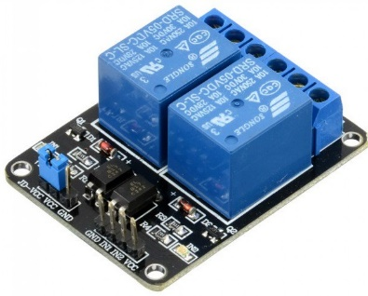

And this is how you connect it:

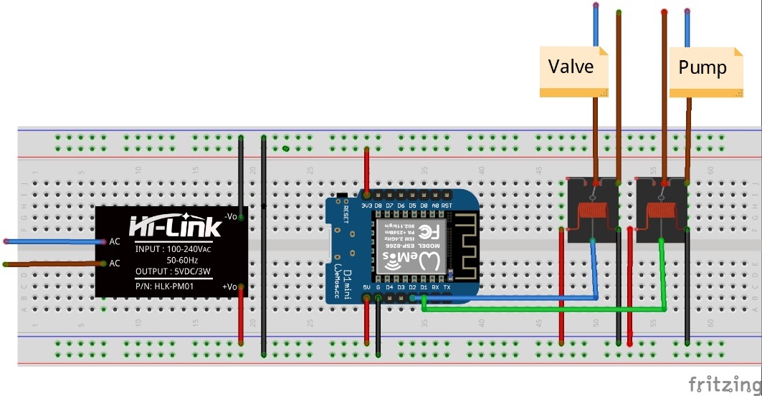

Note that the relay on the schematic looks totally different than the one on the photo, this is because I couldn't find a better picture for the schematic. They operate the same though: you power the relays with 5V (and ground) and you operate it with a 3.3V signal. Turning the signal on is called the HIGH state (is 3.3V) and turning it off is the LOW state (=ground). On the other end of your relay you 'break' one of your wires, feeding the pump and valve, in two and feed those into the relay, connecting it such that its NORMALLY OPEN. This means that if the relay is OFF then the actuator is OFF and the valve is CLOSED. Dito for the pump. Note that I use 'pin D1' on the Wemos for the Pump channel and 'pin D2' for the Valve channel.

On the photo of the relay you will see that the V, G and Channel 1 and 2 pins are all next to each other! On the other side of the relay you see 3 connection points per relay; the one in the middle is connected to you mains, the one left is the 'normally closed' the one right is the 'normally open' (there are usually either pictures on that side depicting an open and closed switch or words: no/nc) to show what is what.

The above relay schematic is used to operate the pump and valve of a single zone distribution unit. I have one floor with 4 separate zones however so that unit requires a 5 channel relay (as I could not find those, I ended up using a 6 channel relay). These 6 channel relays look exactly the same as the 2 channel units, but with 4 additional relays (and 4 additional pins). The 3 additional pins/channels I needed to connect to the Wemos (next to D1 for pump and D2 for zone 1) are: D5, D6 and D7. These 5 pins (D1, D2, D5, D6 and D7) are safe to use for this purpose. If you need more pins in case you have even more zones then I would advice to add an additional Wemos unit because you cannot safely use the other pins. Why? E.g. the Tx/Rx pins on the Wemos are used for communication with the PC to upload firmware, if you start using these for your relays as well strange things can happen, like being unable to upload any firmware. I'm not saying its not possible, but it will require testing, trial and error. I didn't need any more pins so I used the safe ones.

**Central Intelligence Unit (operating the central heating)**

Next to the relays to operate the distribution units, there is the relay that operates the central heating unit. Most modern units have build in connectors which you can use to operate the heating system. How…? You will need to read the technical manual to figure that out, but there usually are 2 options:

1. The "Open Therm" standard, which is a 2 wire connection which can operate the unit in a smart way (like modulating the temperature depending on the heat request). This requires some intelligent coding.
2. An on/off connector which again is a two wire connection.

For floor heating you do NOT want to use the Open Therm as you will be heating up the water to a low temperature anyway and the distribution units are the ones doing the 'smart' work. Next to that I've found out that its actually advised by experts to only use on/off if you only have floor heating!

The biggest advantage however is that the on/off system can be operated with a simple relay! Shorting the two wires will initiate the heating and disconnecting the two wires will stop the heating. So for the final and most important part you again can work with an electronic scheme similar to the distribution units. However as the Wemos devices sometimes get disconnected and you do NOT want this for your central heating unit, some redundancy is required. Which results in the following rather interesting schematic:

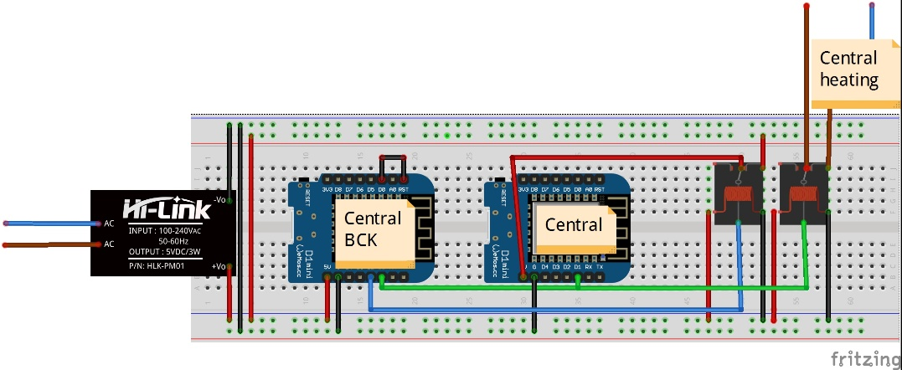

How does this work? As you can see I'm using two Wemos devices, where one is connected to the 2nd relay. These two units I call CENTRAL and CENTRAL BACKUP (BCK). They both do nearly the same thing: operate the central heating (green wire). With one distinction: CENTRAL usually operates the system, but when it goes offline for more than 20 minutes, BACKUP kicks in and first resets CENTRAL by turning the relay to which CENTRAL is connected off and back on. If that is not enough (so CENTRAL remains offline) it takes up the job of CENTRAL completely. CENTRAL itself checks whether its off- or online and in case its offline for longer than 20 minutes it will set the relay pin to the heating system (D1) to LOW=OFF, effectively relinquishing full control to BACKUP.

And what is that black wire doing between RST and D0 on the BCK unit? This connection is required to be able to put that unit to sleep (and let it wake up occasionally) but we go into that part later on.

**Cycling along (Implementing the maintenance cycle)**

As mentioned earlier, one of the issues I encountered is that the valves got stuck, not the actuators (the white knobs), but the actual valves inside the distribution unit. It turned out that it wasn't too hard to fix that but it ***was*** the reason for our last cold house during the winter. To prevent this issue from happening at all I needed to implement maintenance cycles which runs when required. Again after some googling I figured that switching the valves (open - close or close-open) every 12:00 hours and running the pump at least 5 minutes every 12 hours is a prudent method to prevent both from getting stuck.

Fortunately when building a 'smart' system its really easy to build this into your code with a couple of timers. These timers are reset every time the valves switch state or when the pump is turned on (due to heat request by the thermostats). If no heat request is asked for more than 12 hours the maintenance cycle kicks in. Or in case a valve is in the open state for more than 12 hours (so hasn't changed state) it too goes through a close-open cycle.

All this is done in the code that runs on the Wemos devices. I will cover this in more detail when I get to that topic (code).

But before we go into the code, lets first finish up on the hardware part and step into a subject I have not covered yet...

**Connecting the dots (Soldering and crimping cables)**

This subject is really learning by doing, there are fortunately quite a few youtube tutorials on this matter. The ones that I would suggest are:

[Soldering Tutorial for Beginners: Five Easy Steps](https://www.youtube.com/watch?v=Qps9woUGkvI)

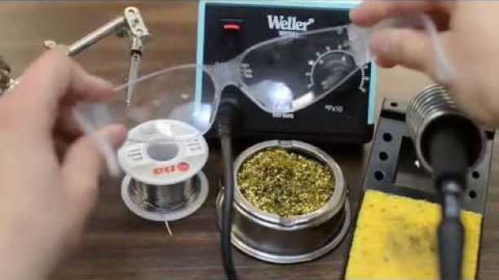

and [How to crimp your own Dupont wires and connectors](https://www.youtube.com/watch?v=DNnzV1hkRXI)

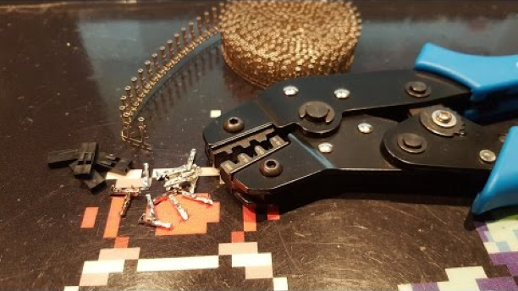

The only piece of advice that I can add to the 2nd vid is that its way easier to instead of soldering the wire initially in place is to use some small pliers to crimp the v-shape part of the connector with a normal set of pliers so the wire stays in place. This is a much faster method and works as well.

Next to this you will need to know how to use 'heat shrink tubes', which is fairly easy to do but here's a vid showing the different methods:

[How To Use Heat Shrink Tubing](https://www.youtube.com/watch?v=Y8wjv6lj5KU)

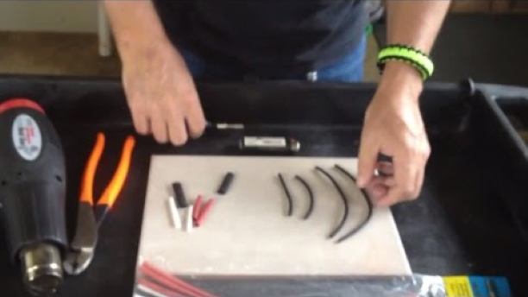

The heat shrink tubes are mainly used to wrap up or shield any exposed wire to prevent: lethal damage to yourself with exposed 'mains' wires and electrical shortages between two wires that are close to each other (which they will in case of electronics!).

After you had some exercise with this we can start building the electronic circuits.

Earlier I've shown you the electronic schematics on a 'breadboard' this breadboard is ideal to swiftly setup an electronic scheme and test it, but to eventually build your unit you have to start crimping, soldering and shrink tubing everything up. Given that I had to build 7 thermostats, 4 relays and one central unit (I'll get to that one later) this was a LOT of work:

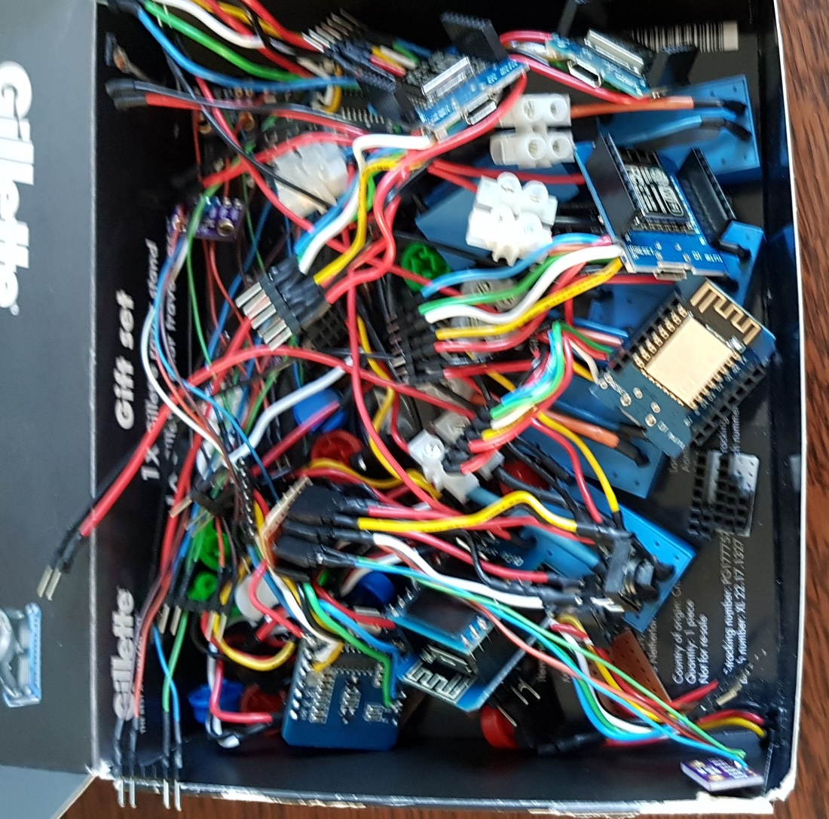

I've already given the schematics for all three circuits so next a breakdown on how to actually create the units.

**The Thermostat**

The Thermostat consists out of a power supply, a Wemos D1, an OLED screen and 2 buttons (+/- temp). I've created the wiring such that they all connect correctly using a 'connector box' which looks like this:

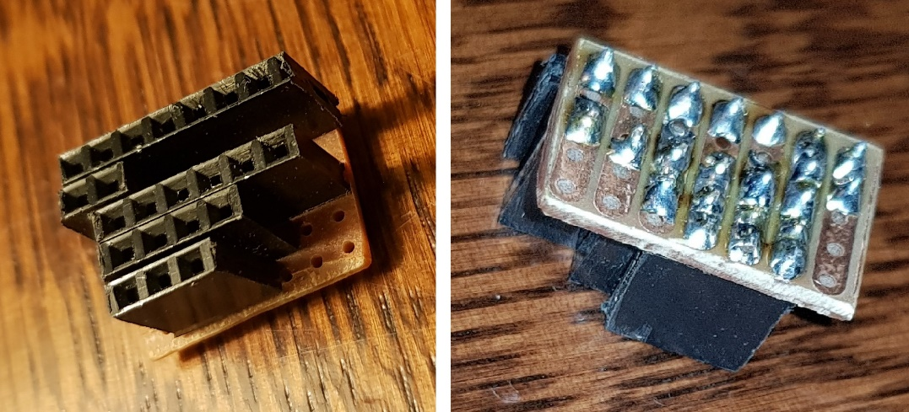

This consists out of a small piece of PCB board with copper strips connecting 5 rows and in total 7 pins wide. On top of it I've added female headers and soldered them to the pcb board on the back. I've created more of these 'connector units' which are all created with the same above principle.

As you can see from the connectors, this requires the pins of the plugs to be correctly aligned, here's a schematic overview of how they are aligned:

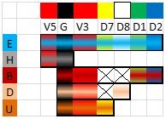

This might look a bit daunting so let me walk you through it:

* Top line are the colors of the wires used
* Second line are the pins used (so **5 V**olt, **G**round, **3**.3 **V**olt, D7, D8, D1, D2
* Lines 3 to 7 is the actual 'connector box' as seen in the picture, here all vertical lines are connected as you can see in the right connector photo. So e.g. all black 'Grounds' are connected. The crossed out cells (X) are not connected.  
  On the left of the schematic overview you see the colored fields with a single letter for the respective plug:
  + **E**(SP8266) = Wemos D1
  + **H**(ilynk) = Power supply; voltage AC-DC step down convertor
  + **B**(ME 280) = Sensor
  + **D**(own button) = Push button to lower temp
  + **U**(p button) = Push button to higher temp

Here the schematics of those respective plugs including the advised lengths of the connected wires (though in retrospect I think most could be ~1cm shorter):

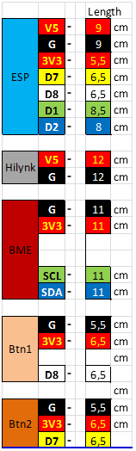

So for example the BME plug (that’s the brown square with BME in it) consists out of a 6 pins wide connector from top to bottom: GROUND ; 3.3 Volt ; NO PIN ; NO PIN ; D1(SCL) ; D2(SDA). See also photo here below. On the other end the wires are soldered to the sensor which schematically looks like this:

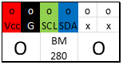

The real life result looks like this:

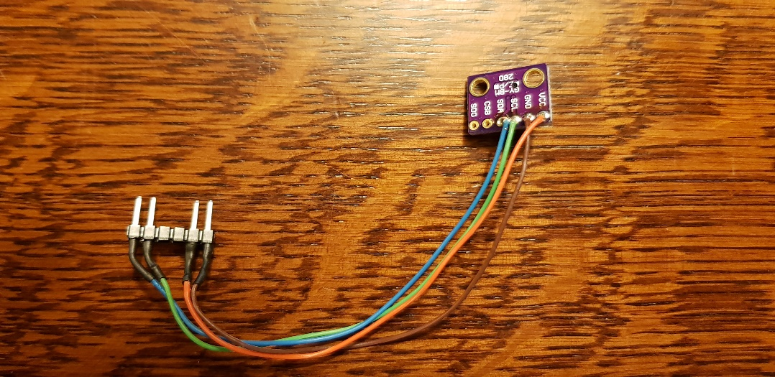

(note that I didn't have any black and red wire in that diameter so I used brown and orange). I use AWG 24 for all wiring, except for this sensor where I dismantled an old internet CAD6 cable and pulled the wires from it (which doesn't have black and red).

Next up the two buttons, the one with the white wire is the - (lower temperature), the one with the yellow wire is the + (higher temperature).

Now if you look carefully at the schematics you notice that a (10kΩ) resistor is required in the schematics, here an schematic view of how I soldered that:

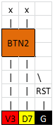

How does this work? It’s a pushbutton (so its only 'on' when you actively push it). In its 'rest' (unpushed) state the pin D7 is only connected to the Ground so its LOW. When you push the button, the circuit connects and a 3.3V flows from V3 to D7 so its HIGH. This state change you can read using code.

Note that there also runs a current from V3 straight to Ground when you push the button, if there would be no resistor the current would be damagingly high and you can potentially burn your unit. Typical resistor used for this is 10kΩ.

This is the end result:

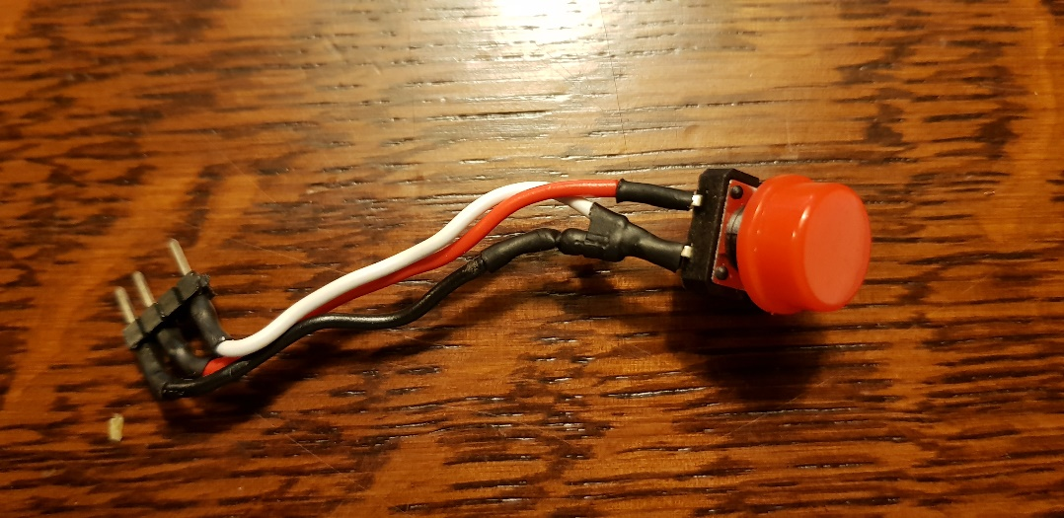

(note the empty pin between the red and white wire !)

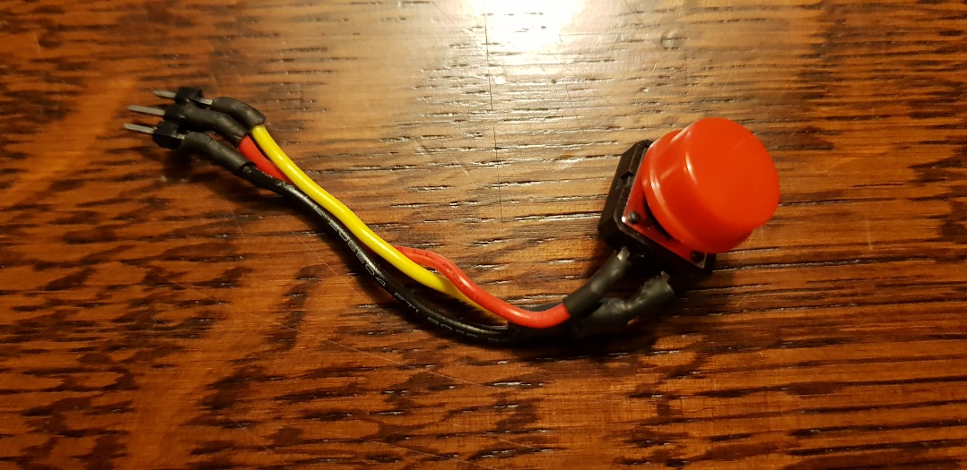

But where's the resistor? I've hidden it in the shrink tube, here a close up:

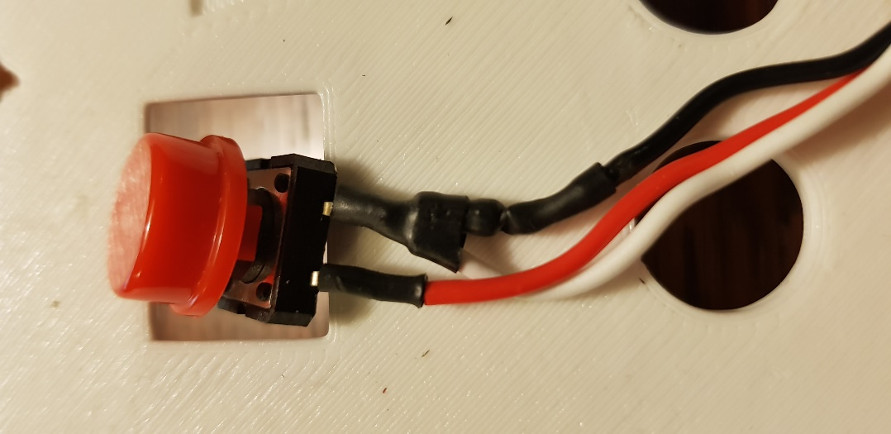

Then there is the connection to the power supply, the AC 2220V--> AC 5V Hi-Lynk step down convertor:

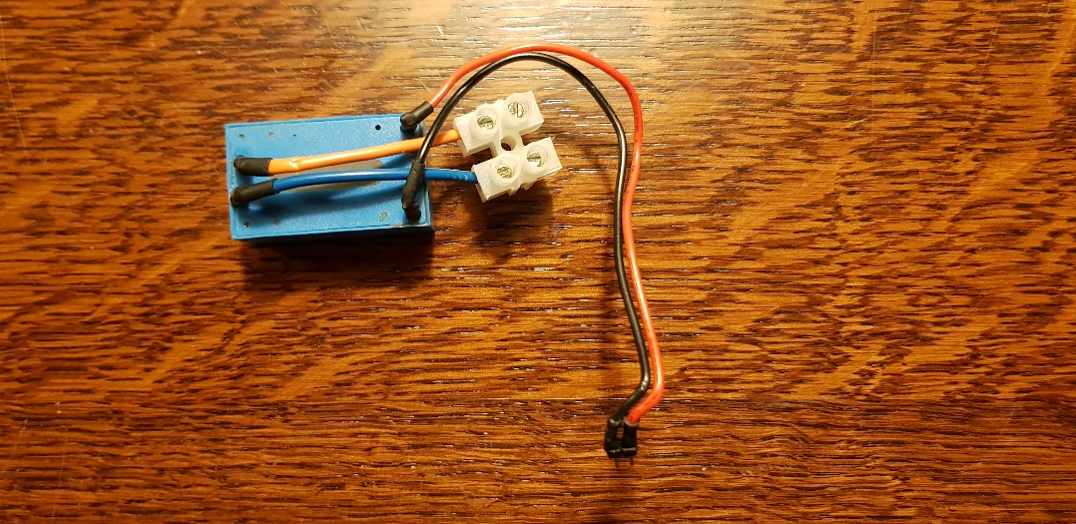

The orange and blue wires are connected to the mains. The black and red end up in a 2 pin connector.

The hardest soldering part is the Wemos… from the connector schematics you can already conclude that there are a LOT of wires going in, here another schematic overview of how the wires are connected to the Wemos D1 mini:

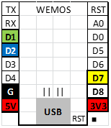

And here a couple of photos to show the real life result:

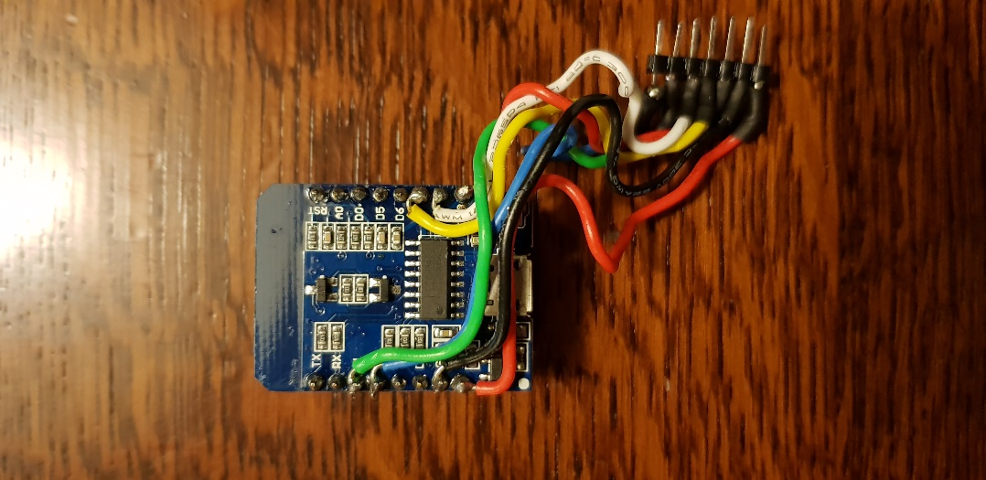

So why did I solder them on the back of the unit? Because there's an OLED shield on the other side…

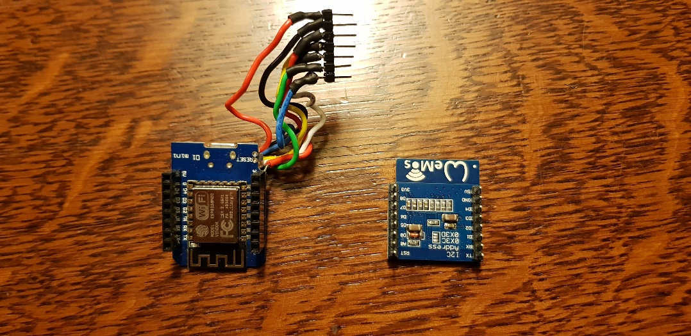

Top of the wemos (note the female connectors soldered on there) and the bottom of the OLED shield (note the male connectors sold on there).

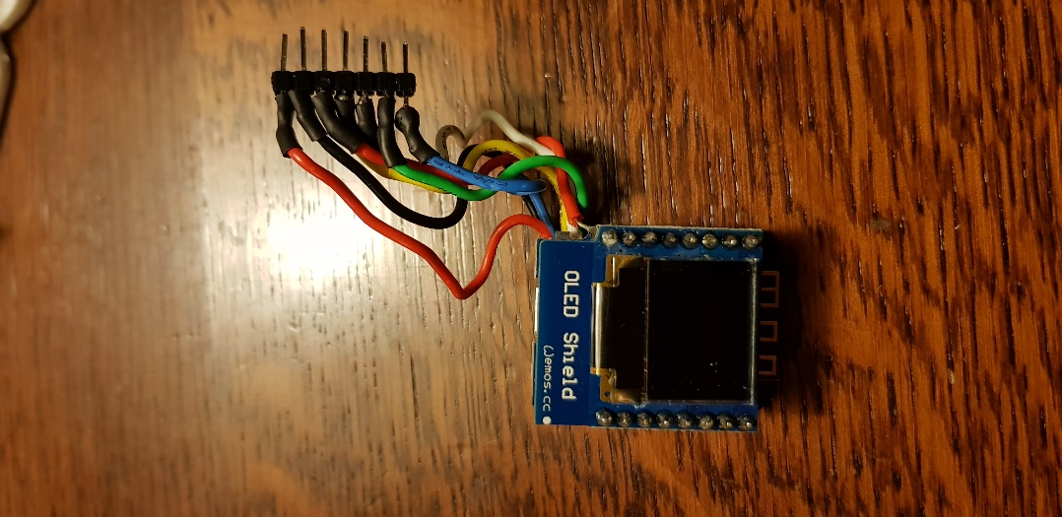

OLED shield on top of the Wemos.

Putting it all together:

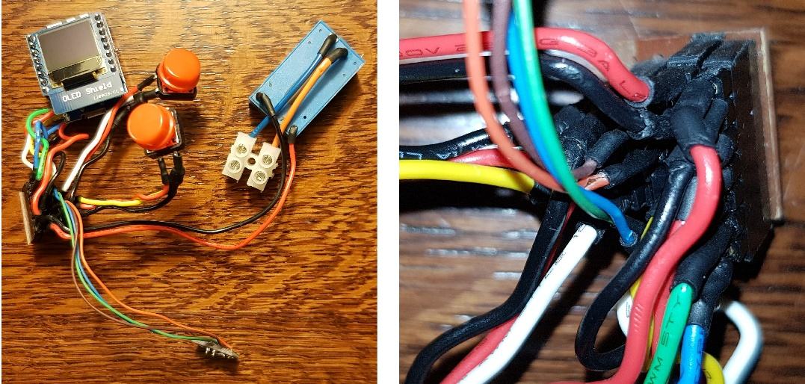

Right pic shows a close up of the connector unit. Note that all colored wires are aligned (so all blacks on one row, all red, all white, etc).

Obviously this is not yet the end result, we still need a wrapper, but we get into that later.

**The Relay**

Although the final wiring of the relay can look a bit daunting, the soldering part is fortunately limited. As this unit is next to the heating distribution unit anyway, I don't really need to worry about how bulky it gets. For this reason I did a lot less soldering and used a crimping tool to add Dupont connectors to the wires. I've already provided the schematic overview of the wiring and a tutorial on crimping so I won't go into detail, here the real life end result:

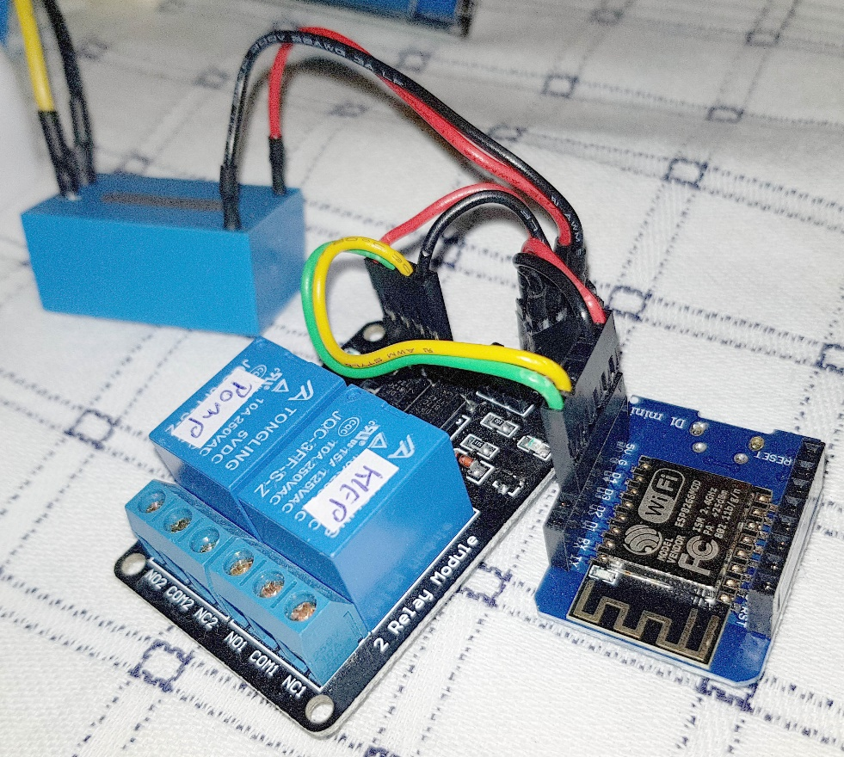

Now there is one thing of note here: because both the Wemos and the relay both require a 5V feed (and ground) I had to come up with a way to easily connect those wires so I used (again) a DIY connector box (on the photo you can see the red and black wires go in there). This one is similar to the one I made for thermostat, but much simpler. It looks like this:

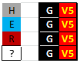

So we have a connection for the **H**i-Lynk, **E**SP8266, **R**elay and **?**. I've already have something in mind for the **?** slot, but as I'm writing this I have not received anything and its not a vital part of this setup anyway. My point here is: if its easy to create some redundancy: do so!!

**CENTRAL**

This is basically the same as with the above relay. What's different is an additional Wemos and slightly different wiring. You can use the earlier CENTRAL schematics as reference for the wiring, note that I here too used a small connector unit to connect the Hi-Lynk with the relay and the two Wemosses. There's a second connector unit if you look carefully, this one is used to connect the green wires from Central, Backup and to the relay, which operates the CV channel of the relay.

The piece of black tape on the left is the connection to the mains which I'll go into detail later on. You might also notice that its inside a nice white 3D printed box, again a detail to which I come later.

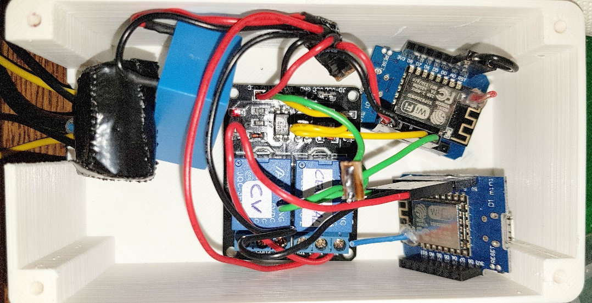

What I've mentioned earlier is the extra black wire used for the BCK unit. This is used for 'Deep Sleep' of the unit. 'Deep Sleep' is a state of the Wemos device where the power consumption is really low, that’s not really the reason I use it though, I just want to limit the Wifi connections of all the units so I leave it sleeping. During its sleep it counts down to 0 (from a number give) and when it hits 0 it wakes up. However in order to be able to wake up you will need to short circuit

the D0 and the RST pins. *That* is what that black wire with Dupont connectors is for.

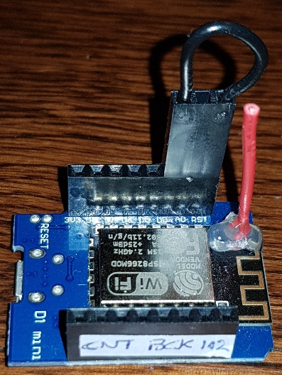

And now you're wondering, what on earth is that red thing glued to the Wemos…?

**Improve communication (optional: add antennas)**

This is an optional topic and is not really required to get this stuff up and running. However if you are worried about proper communication between your router and the Wemos units, you can solder a small antenna onto the existing antenna. There are strict rules for lengths (getting it wrong can have an adverse effect and even shorten the life of the Wemos unit). The length of the antenna must be a quarter of the length of the 'wifi wave' with which its communicating. Typically this is 2.4GHz or 5GHz. 5GHz is short range though so its wise to use 2.4GHz. The router however works with 'wifi channels' which means that it covers a range of frequencies all close to eachvother. The average wage frequency is: 2,448,000,000 Hz. 1 Hz or 1 Hertz is one full wave per second. So the wifi signal is 2.4 billion waves per second. The wave travels with the speed of light, which is: 299,792,458 meters per second. With that its easy to calculate the wave length: which is [the speed of light] / [the wave frequency] = 299,792,458 / 2,448,000,000 = 0.1225 meter = 12.25 cm. So a quarter of that is: 3.1 cm. You can use the AWG 24 wire for it, strip a few mm on one end and bend it in a 90 degrees angle. This you can solder onto the Wemos antenna here:

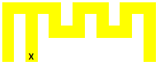

Why there? I simply measured the wifi signal strength while moving the antenna over the entire Wemos antenna surface and the signal was strongest when I put it there. Feel free to test this yourself :D

Once you've soldered this you will need to glue this into place with a glue gun or else if you put too much force on the antenna you will rip the Wemos antenna from the board (which I did initially…) I can assure you that in that case you end up with a REALLY crappy

signal strength… The end result looks like this:

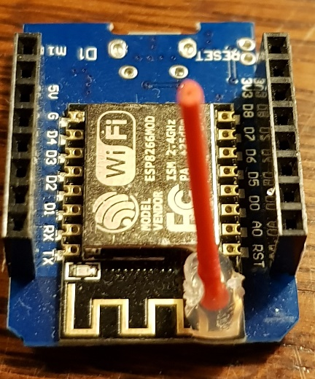

It’s a bit hard to see due to the crappy glue job, but it really is soldered onto the end of the second line of the antenna.

**Making it Smart part I (The Code)**

The next two steps are actually HUGE and took place throughout the entire project and will continue beyond it (as I expect to further fine-tune small stuff later on as I keep learning).

These two steps are:

* Writing the actual code for the Wemos units and
* Letting it correspond with the Blynk app.

I have used a surplus amount of comments in the code so I am not going into too much detail of how its coded and why its coded the way it is. Overall I have rewritten the program for the thermostat 3 times before I ended up with the version it is now. Reason: I kept learning better methods or I stumbled into a too big hurdle. What I constantly kept in mind is that the code has to remain readable after I stop looking at it. So I've distanced myself from too complex schemes where 'actual' C++ code comes into play. What I'm trying to say is this: once you get the hang of coding it should not be too hard to get to understand how my code works.

How to get it working? The core of it is: flash each unit with its corresponding code base and it will work. Alas to get it working for *your* situation, you will need to delve into the code and set it up such that it will work for your specific situation. This because the current setup consists out of: 7 thermostats communicating with 4 relays of which 1 relay operates 4 valves. Its possible that you have 4 floors with each 4 valves or only 2 floors each with only one valve. You will need to adopt the code accordingly. So let me talk you through that part.

'The code' consist out of 4 'parts' or 'code bases', these are:

1. A '**Header**' file, this contains code, definitions, inclusions etc. that is used by ALL units. So instead of having to change/add/comment it 3 times, I've grouped this together into one file. Note that you must place this file in the Arduino library directory, together with the other library files required for this project. It goes beyond this write up to explain how to do that, there are many tutorials on that subject. The libraries required for this project can be found at the top of the header and consist out of all the lines with *#include*. So for example: *#include <ESP8266WiFi.h>*  means you need to download and install the ESP8266Wifi library.
2. The '**Thermostat**' files, this contains the code used to flash the thermostat units, note that because there are 7 units you would basically need a different code base for each unit, but I used a simple trick for that.
3. The '**Relay**' files, this contains the code used to flash the 4 relays and same trick applies: 1 code base for 4 units.
4. the '**Central**' files, this contains the code used to flash the CENTRAL unit and the CENTRAL BCK unit, with again the same trick.

What do you need to change when you're going to use this?

1. '**Header**' file: in this file you need to change:

* **SSID** (the login name to your router)
* **Pass** (the password to your router)
* **fwUrlBase** (the IP address to the local webserver, IF you have any)
* The **IPAddress** server (the IP address of your local server.
* The token references, which look like this:  
  *#define auth_CENTRAL "1efa4exxxxxxxxxxxxxxxxxxxxxcacaf"*

These are unique ID codes generated by Blynk when you add communication devices (like the Wemos) to the app. By this reference code a 'Wemos device' is identified. Note that I used "auth_T_*LIVING*", "auth_T_*STUDY*", etc as variable names, you can change these names into something more meaningful for your specific situation, but DO make sure that you change this throughout ALL the code (so wherever these are used in Header, Central, Relay or Thermostat code base).

* The relay-pin check pins. This is line:

*byte rlyValveOn_PIN[7] = {V51,V51,V51,V52,V53,V54,V51};*

These pins are used to show in the app whether a Valve is OPEN or CLOSED. You can't (shouldn't) access the digital states of the physical pins directly so when you change the valve state you also change one of these pins. Now if each relay only would have 1 valve they can all communicate over pin V51 (each device has its own virtual pin set) however on the third floor there is one relay unit which operates 4 valves (so 3 additional valves) hence: Floor 1: V51, Floor 2: V51, Floor 3: V51, V52, V53, V,54 and Floor 4: V51, which results in the above array.

2. **Thermostat**. These consist out of three files: Heating_Thermostat.ino, notifications.ino and comments.ino. The first one is the main code file and the one you need to edit for you use. The second (notifications) concern the blynk notifications send by the thermostat in case stuff goes haywire (e.g. temp > 60C). You can leave it or change it as you like. The last file (comments) is not required, but contains some musings of me, this is NOT used by the code, so leaving it out will have no effect at all.

In this code base I'd suggest you change the following lines:

* *const int FW_VERSION = 54;*

This is the version number, if you like you can set it back to '1'. Note though that this MUST be an integer (a whole number).

* *#define ROOM 1*

This is the 'trick' I was talking about earlier. If you change this into e.g. *#define ROOM 2* then the code compiles for room 2, same for 3,4,5,6 and 7. The difference lies with this part of the code:

*#if ROOM == 1*

*char ESP_NAME[] = "ESP_THM_LIVING";*

*char auth[] = auth_T_LIVING; // assign correct token number, stored in W42 header*

*char auth_RLY[] = auth_R_FLOOR_1; // auth_R_FLOOR_1, auth_R_FLOOR_2, auth_R_FLOOR_3, auth_R_FLOOR_4*

*const float WIFIPOWER = 0; // range from 0 to +20.5dBm, where 0 is NOT off, but the lowest setting*

*const String idColor = CLIVING;*

*float TCalibration = -1.2; // correction on displayed T*

*#endif*

Each Thermostat has its own section like this and if you change the

*#define ROOM 1*

Line from e.g. 1 to 2 then the code will use that section corresponding with 'room 2'. These sections you will need to change to your situation. Here a breakdown, line by line:

*char ESP_NAME[] = "ESP_THM_LIVING";*

This is the unique name of the unit and if you're using OTA, this is the name that shows up!!

*char auth[] = auth_T_LIVING;*

IF you change the 'living' part in the header file, you'll need to change it here too. This refers to the token of THIS unit. So the 'token' corresponding with the thermostat in the living room.

*char auth_RLY[] = auth_R_FLOOR_1;*

This is the connection between the Thermostat and the relay. So Thermostat '1' corresponds with relay 'floor 1'. Again you can change this according to your situation.

*const float WIFIPOWER = 0;*

By default all wemos wifi power output is set to 21dB this is a REALLY strong signal which can interfere with other signals, so getting this as low as possible is best. '0' is the lowest setting but this does NOT mean that the power output is 0. This is a bit of trial on error, but in my house I can set all units to 0 without issue.

*const String idColor = CLIVING;*

Widgets in blynk can have different colors and I use different colors for different units. The colors are set in the w42_header file and you can change them there or in this line. Changing it means that certain widgets will change color.

*float TCalibration = -1.2;*

What the thermostat 'measures' and what is reality does often not coincide so here you can calibrate your sensor to the correct T.

*bool scheduleWeekDay[MAXSCHEDULE][7]*

Specifically the '7'. This indicates the number of room/thermostats your using. Note that the 7x 'false' per line need to be adjusted accordingly!

3. **Relay**. Same applies as with Thermostat, next to the main file Heating_Relay.ino, here too is a comments.ino file and additionally there is a 'terminal_commands.ino' file which contains an overview of all the commands that can be given from the Blynk app terminal to the relay unit.

Here also in the main ino file you will find the different 'unit' sections which can be change by changing the line:

*#define FLOOR 4*

Which will compile the code for the relay on the 4th floor. You will notice the that *#if FLOOR ==* sections are nearly exactly the same as for the Thermostats. The differences:

*const int ROOM = 1;*

This is an additional line used to check to see to with which room this relays corresponds.

*char auth_THM[] = auth_T_BATH; // D2*

*char auth_THM1[] = auth_T_BED; // D5 used on floor 3*

*char auth_THM2[] = auth_T_LAUNDRY; // D6*

*char auth_THM3[] = auth_T_ARTHUR; // D7*

This you'll see for the relay on the 3rd floor and again signifies the correspondence between the relay and the thermostats.

You can add or remove thermostats per floor however you like BUT if you use more than one thermostat on one floor then you need to change these secitons in the code as well:

*#if FLOOR == 3*

*WidgetBridge bridge_thm1(channel2_PIN);*

*WidgetBridge bridge_thm2(channel3_PIN);*

*WidgetBridge bridge_thm3(channel4_PIN);*

*#endif*

and

*#if FLOOR == 3*

*switch(i){*

*case 3: bridge_thm.virtualWrite(maintOn_PIN, maintenanceOn_V[i]); break;*

*case 4: bridge_thm1.virtualWrite(maintOn_PIN, maintenanceOn_V[i]); break;*

*case 5: bridge_thm2.virtualWrite(maintOn_PIN, maintenanceOn_V[i]); break;*

*case 6: bridge_thm3.virtualWrite(maintOn_PIN, maintenanceOn_V[i]); break;*

*}*

and

*#if FLOOR == 3*

*bridge_thm1.setAuthToken(auth_THM1);*

*bridge_thm2.setAuthToken(auth_THM2);*

*bridge_thm3.setAuthToken(auth_THM3);*

*Blynk.syncVirtual(4,5,6);*

*#endif*

Then there are a couple of constants that need to change like:

*HEATER_RLY_PIN[7] = {D2, D2, D2, D5, D6, D7, D2};*

This relates to the physical pins to which the Valve is connected. This is D2 by default except for the 3rd floor where it is: D2, D5, D6 and D7. Again change according to your situation.

heatOn[7], maintenanceOn_V[7], maintenanceTimer_V[7] and stopValve[7]. These again refer to the 7 valves, if there are less (or more) change the '7' accordingly and update the number of 'false' to the correct number on the rest of the line.

4. **CENTRAL**. Here too you will find a comment.ino file which is not used. What you need to change if only one line:

*#define BCK 0*

Into

*#define BCK 1*

The first line will (0) will compile the code for the CENTRAL unit. The second line (1) will compile the code for the BACKUP unit.

*tokenRLY[4]*

Refers to 4 Relays ESP's change number according to your situation

*tokenTHM[7]*

Refers to the 7 Thermostat ESP's, again change accordingly

*heatOn[7]*

I hope its obvious by now…

**Blynk me up Scotty! (making it smart part II: Blynk)**

The base code for the units is littered with 'vpins' aka 'virtual pins'. They are all defined in the header file like this:

*#define currentT_PIN                V10*

There are roughly 50 of these defined and they all are used by Blynk. The point is is that e.g. 'V10' is a 'memory container' where you can put stuff in, like the measured temperature in a room. Which is done in this line:

*Blynk.virtualWrite(currentT_PIN, floatToString(currentT,1));*

This line writes the value currentT (current measured temperature) to the 'virtual pin' V10, this value is stored on the server (the Vpin manager) and the app on the phone reads these values from the server and shows them on your phone:

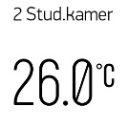

('Stud.' == Study; 'kamer' == 'Room' - its Dutch)

This is a 2 way street where you can set values from the Wemos units to the server but also the other way round, like in the case of say: target temperature:

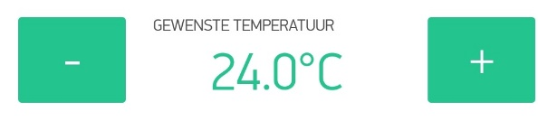

Yeah it’s a Dutch app… all the code is in English, the interface part of the app is in Dutch though ('Blynk' itself is in English!!, just the words I used are in Dutch). Fortunately its easily changed!! This one says 'wanted temperature'.

You can find the reference to the target temperature and this widget back in the code here:

*#define homeTargetT_PIN V32*

So the app updates V32 with the new value and this is send to the corresponding Thermostat. On the thermostat though there are also 2 physical buttons with which you can also set the target temperature! Hence this works 2 ways. If I change the temp using the buttons the value in the above screenshot will change accordingly.

Fortunately Blynk allows to share the app with a simple QR code so you don't have to build it from scratch. You can download the entire app using Blynk and showing it this:



Do make sure though that you install this on a local server as this requires a LOT of energy units (in Blynk).

What does this look like... queue the screenshots:

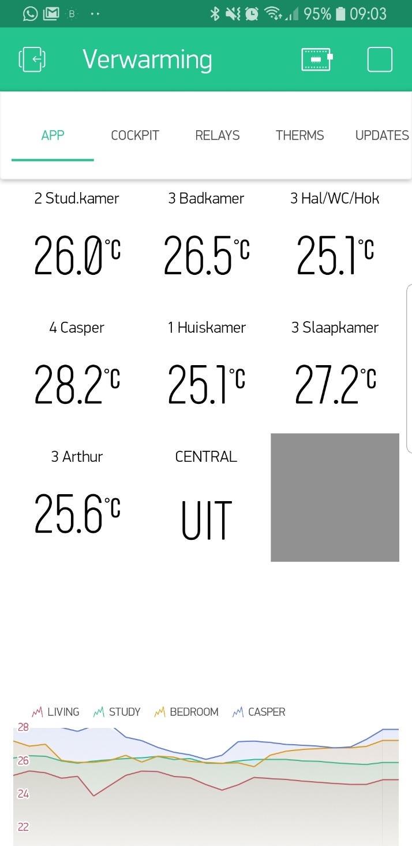

'Verwarming' == 'Heating'. At the top you can see 5 tabs: app, cockpit, relays, therms and updates. You're currently looking at tab '**app**'.

'App' is the main screen that shows you an overview of the current T in each connected room. It also shows whether CENTRAL (heating) is ON or OFF (=UIT). Every 'tile' contains a temperature is also a button. Tapping on it will send you to the detailed overview for that room:

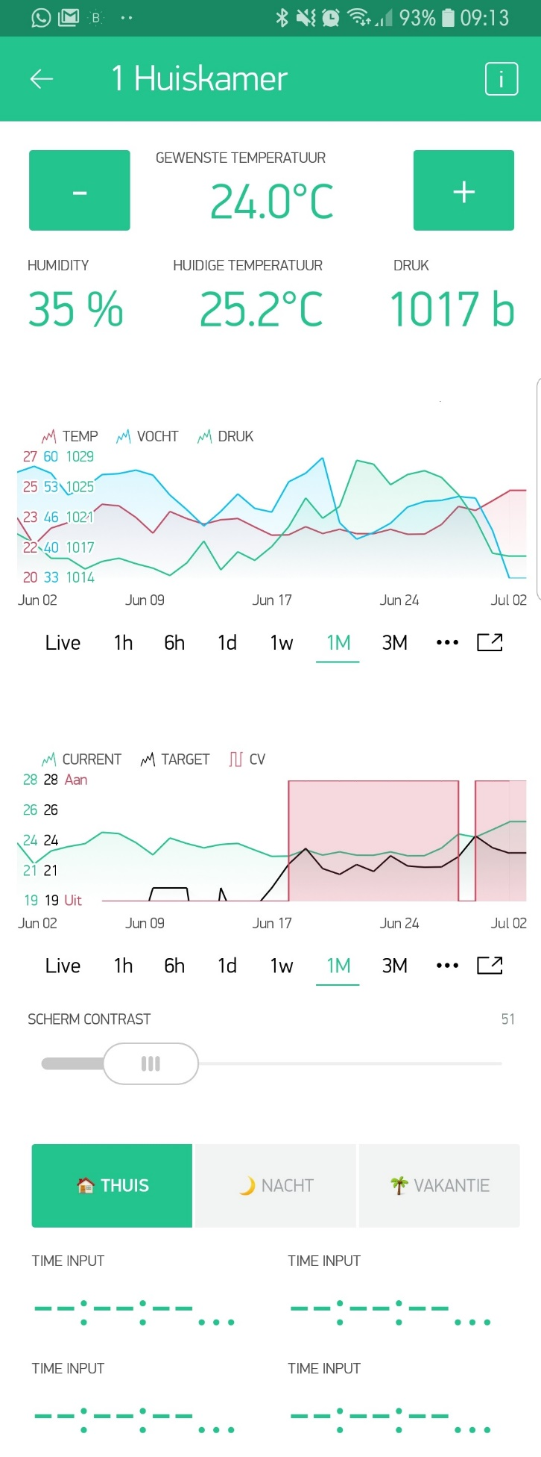

From top to bottom:

1. Name of the room: 'huiskamer' (=='livingroom')

2. Target Temperature

3. Humidity/Current T/Pressure values

4. Humidity/Current T/Pressure values in a graph

5. Yet another graph, this one show: the current T in green, the Target T in black (usually this should be a straight line, but I've been testing a lot so it changed quite a bit over the month) and the Central Heating ON or OFF in red.

6. A slider with the enigmatic words 'scherm contrast' which translates to 'screen contrast'; when I initially installed a thermostat in the bedroom my wife complained about 'bright light', so I added a slider with which you can set the OLED intensity. Note that sliding it to 0 turns off the OLED.

7. More obscure words: 'Thuis', 'Nacht', 'Vakantie' although the icons I added probably gives it away: you can pre-set temperatures per room for 'Home' (so when you're at home during the day), 'Night' (you can lower temp during night time) and 'Vacation' (turn it even lower when you're away for a longer period of time). Should you do this with floor heating? There has been a lot of debate on this but the short of it: yes (in case of Holiday). The 'night' version might be overkill as the response times are slow, but the 'vacation' part is certainly valuable. Just make sure that its NEVER lower than 5C (not good for your house, plants, furniture, etc.).

8. 4x Timer input. These are timer and they correspond with the NIGHT setting. With these you can turn Night ON or OFF:

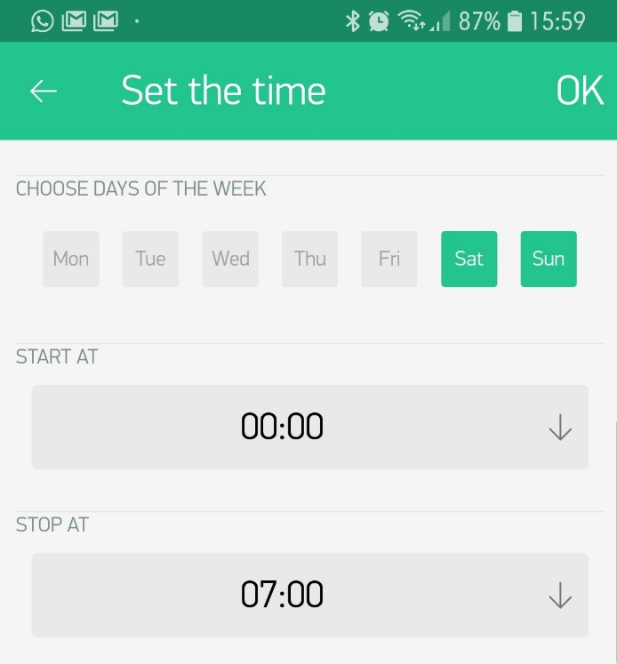

So in this case 'night' on Saturday and Sunday starts at midnight and ends at 7:00 in the morning.

If you click on the CENTRAL tile, that’s the one that says 'UIT' (==OFF) you get a different view:

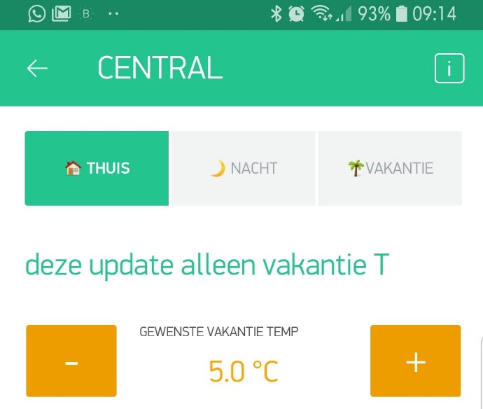

From top to bottom:

1. Thuis/Nacht/Vakantie I've already explained those, the difference is that here you set them for ALL rooms, instead of for just the room you just selected!

2. '*this update only vacation T*' get it?

3. Here you can set the target T during holiday for ALL rooms. This overrides the 'per room' settings. So FIRST set this 'global' one and THEN make some changes per room (yes you can adjust the 'vacation' temperature per room!!).

The next tab is '**Cockpit**'. This is the NERD section and the initial app I created. This gives a quick overview of all rooms and the relays states:

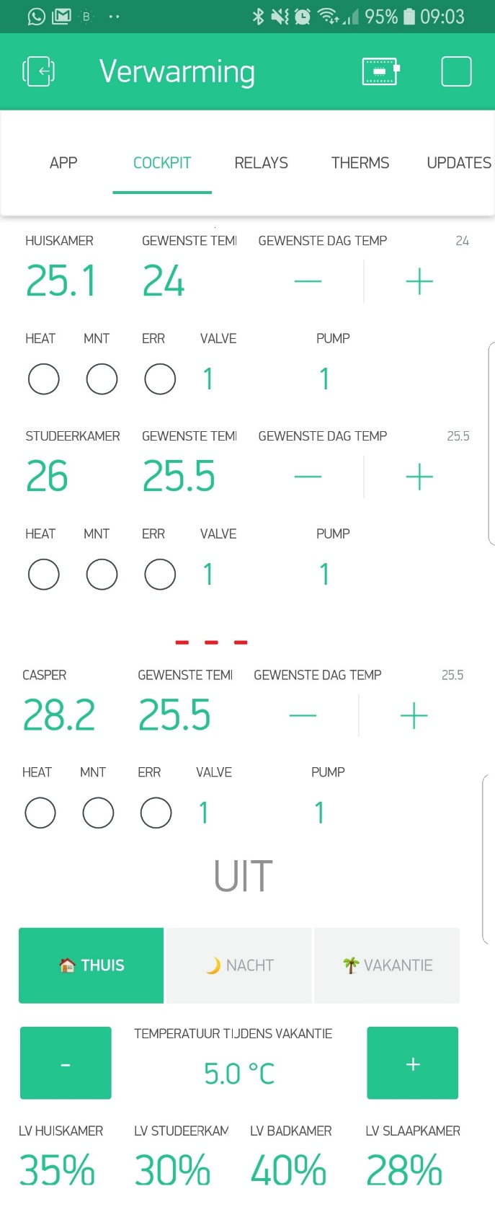

To prevent this from becoming a really long screenshot I've cut out a couple of rooms and replaced those in the screenshot with **- - -**

Again from the top;

1. Huiskamer / Gewenste T / Gewenste Dag T

Temperature in the 'Livingroom'. 'Target T' for that room, +/- buttons to set the 'target day T'. (Note that in contrast to the 'app' tab, these +/- ONLY update the day T NOT the night nor holiday T.)

2. Heat / Mnt / Err / Valve / Pump

'Heat' A 'led' that turns red when the 'Thermostat' asks for heat.

'Mnt' A 'led' that turns red when the Relay is running a maintenance cycle

'Err' A 'led' that turns red when the Thermostat Sensor (the BME 280) reports an error (==gives an unreadable value).

'Valve' and 'Pump' are the Relay states of the valve and pump, where

1==HIGH==OFF and 0==LOW==ON. So in this case everything is off (not so strange as its summer here).

3. rinse and repeat 7 times (3 times in this screenshot)

4. 'UIT' = 'OFF' and is the state of the CENTRAL heating relay!

5.THUIS/NACHT/VAKANTIE. I guess these are familiar now as well. They're the same as behind the central button and thus operate ALL the rooms' states.

6. T during holiday

7. An overview of all (7) humidity's on all rooms (but cut off on this screenshot to the top 4).

Next tab: '**Relays**': if the cockpit did not appeal to your inner nerd, then perhaps this will:

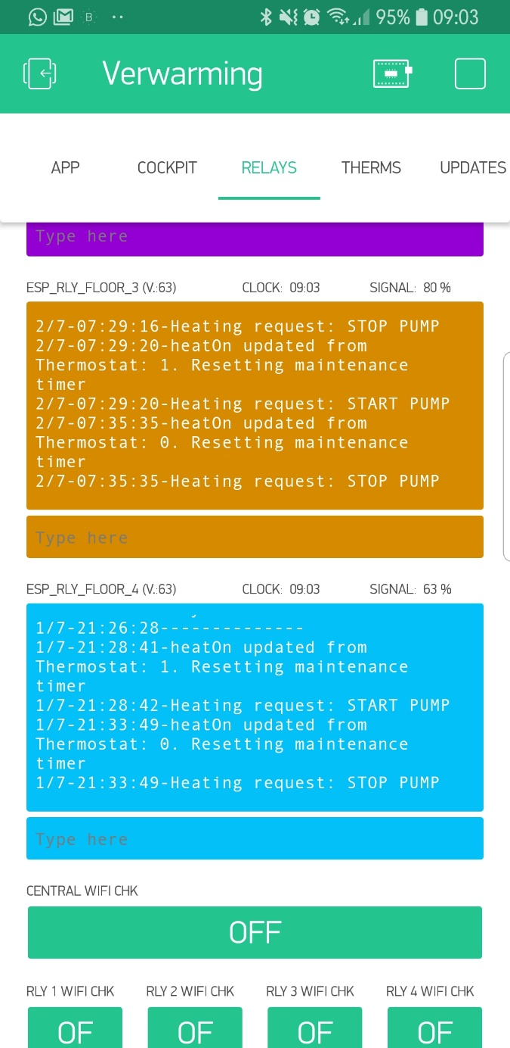

This is the 'back end' output of the code, showing state changes, maintenance cycles etc. Here the 4 floors can be found including CENTRAL and CENTRAL BCK.

You can also enter commands into the terminal. The most used (by me) is 'reset' (without quotes) other commands are 'stop' and 'start'. The relays even have more and you can see an overview with the '?' Command.

Way at the bottom you can find 5 green buttons, called "xxx wifi chk". If you look a the line just above a terminal you'll see this:



The last one: signal strength updates every 1 minute. When you're installing the unit however you would like to know the signal strength immediately based on the current position of the ESP8266 (yes that orientation has a HUGE impact on the strength!!). When you hit the corresponding button e.g. 'central wifi chk' then the Terminal for 'CENTRAL' will start spamming signal strengths numbers (3 per second) allowing you to position the unit correctly). Hitting it again will turn this off.

Final tab: '**Updates**'.

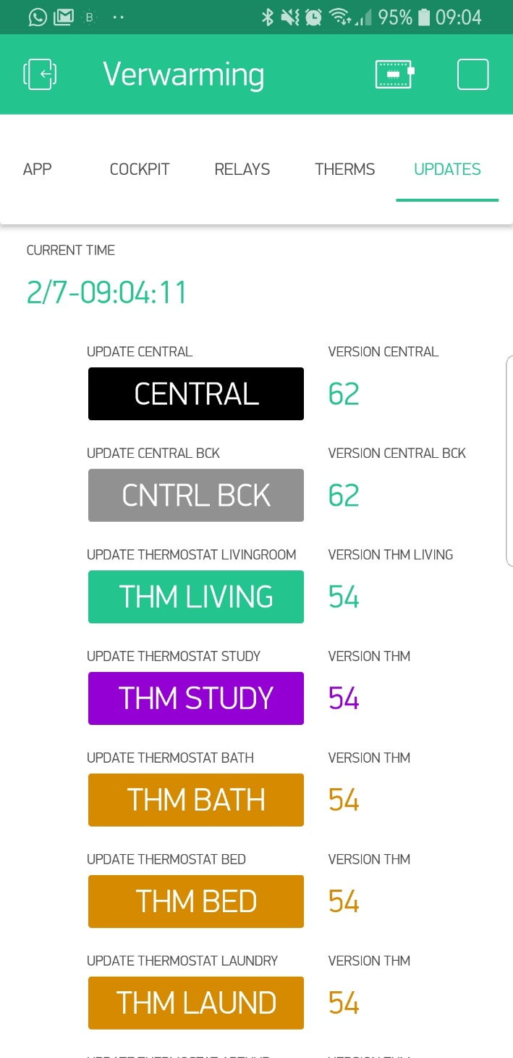

Again a partial screenshot, in total there are 13 colored buttons, with a version number behind it. There function is simple: if you tab on one then that unit immediately starts looking for a firmware update on the server, downloads it, installs it, updates the version number and turns the button OFF again.

**Wrapping it up (3D printing the casings)**

We're not done yet… somewhere along the line I also started working on a casing for the thermostat...as it would finally end up on the wall. Which drew me into the mystical world of 3D printing…

First step here was finding a design program. First thought was using googles 'Sketch Up' but after some digging and reading I fairly soon figured that this would not be the best choice for my situation. After quite a bit of reading I ended up with Autodesk FUSION 360: <https://www.autodesk.com/products/fusion-360/overview>

Which is FREE for the 'home enthusiast' !

So why Fusion over Sketchup? The honest answer: because everyone else said so! But after using Fusion for a couple of months now (and having used Sketchup occasionally in the past) one HUGE advantage is the 'timeline' with 'dependencies'. The short of it: if you create a hole of say 3cm and create your design depending on those 3cm and then later you figure out you've been an idiot and it had to be 4cm, you can go back into the timeline and edit that sketch changing the 3 into a 4cm. Next ALL dependencies change accordingly. That is one hefty feature Sketchup does not have!

How to get to know Autocad Fusion 360? Again: start out with some YouTube tutorials before you dig into this, here's the first one of great series:

<https://www.youtube.com/watch?v=A5bc9c3S12g>

The beauty of Fusion is that its an AWESOME design program and there are endless amount of tutorials and fora to help you out (which I earlier explained is vital for a newbie!!). All the questions I had during my design were swiftly answered with a bit of googling.

The final challenge I faced during the design of the thermostat casing, was a 'heating' issue of the electronics. It turned out that the ESP/OLED/Power supply generated heat that it impacted the BME sensor with about +4C. I wanted to limit that impact so made a LOT of designs and tested those. Here a photo of that history:

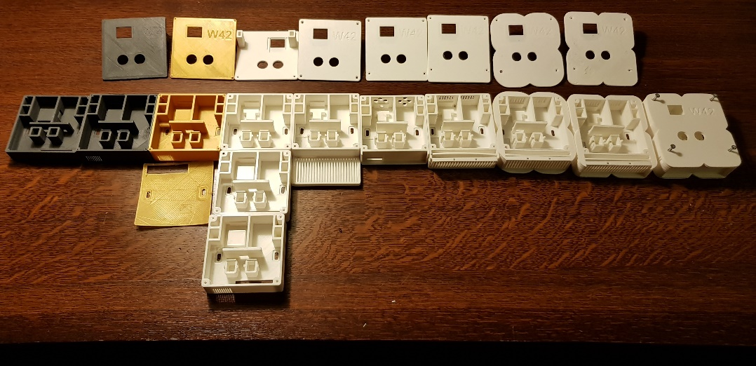

In addition I've made numerous small changes like small 'barriers' to keep the buttons in place, different wiring openings and a 'carrier' for the ESP so the OLED screen aligned with the square opening. The last 2 models (on the right) show a different form factor. This due to a friend of mine who said: '*if you're printing it anyway: why don't you make it look less 'nerdy' by adding some curves to the boxes'*, so I did. The different colors of the boxes are a result of filament that I had available.

One remark on the photo: I've turned the third lid from the left upside down, here you see 2 pillars (which also keeps the other in an angle), these pillars aren't really necessary but they keep the lid in place without any screws, which I thought would be 'handy' (which it indeed turned out to be). Depending on the printer though you might need to file (polish) these a bit for them to properly fit into the shafts.

Here a link to the Autocad file: <https://a360.co/2KVmotX>

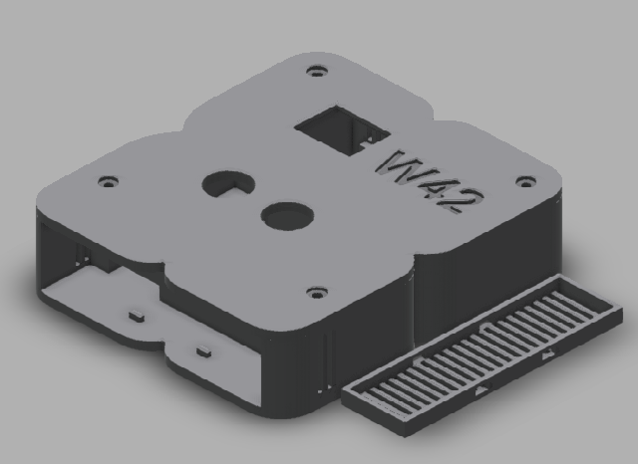

Anything you need to change for these? Well if you have screw holes already in the wall, you could consider moving those in the sketch. In this particular case though I don't think it will be easy. Its probably easier to fill them up and create new ones.

When you have your design ready though, you're not there yet, next you need to turn the design (which is vector based) into an STL file. An STL file contains the surface geometry of an object. The final step is a 3D slicer which turns that surface geometry into small slices or layers, which are the layers that the 3D print is going to print.

BEFORE you create the STL file though, make sure that you only print either the LID or the Box and Roster. If you print the lot in one go then the lid will be fused to the box. You can easily toggle 'bodies' on and off in Autocad. Do this before exporting it to STL.

The last step is dependent on the printer and its of little use to tell you how I did it in my case (there's a program with my printer: load the STL and export the 'print' file. Load that into the printer and start it.). Creating the STL file is also easy, here's a tutorial:

[Exporting STL files in Fusion 360 - Single, multiple bodies and dual extrusion!](https://www.youtube.com/watch?v=JP5UDeBH4y4)



And then finally you can print them and assemble the Thermostats, here the steps in a few pictures:

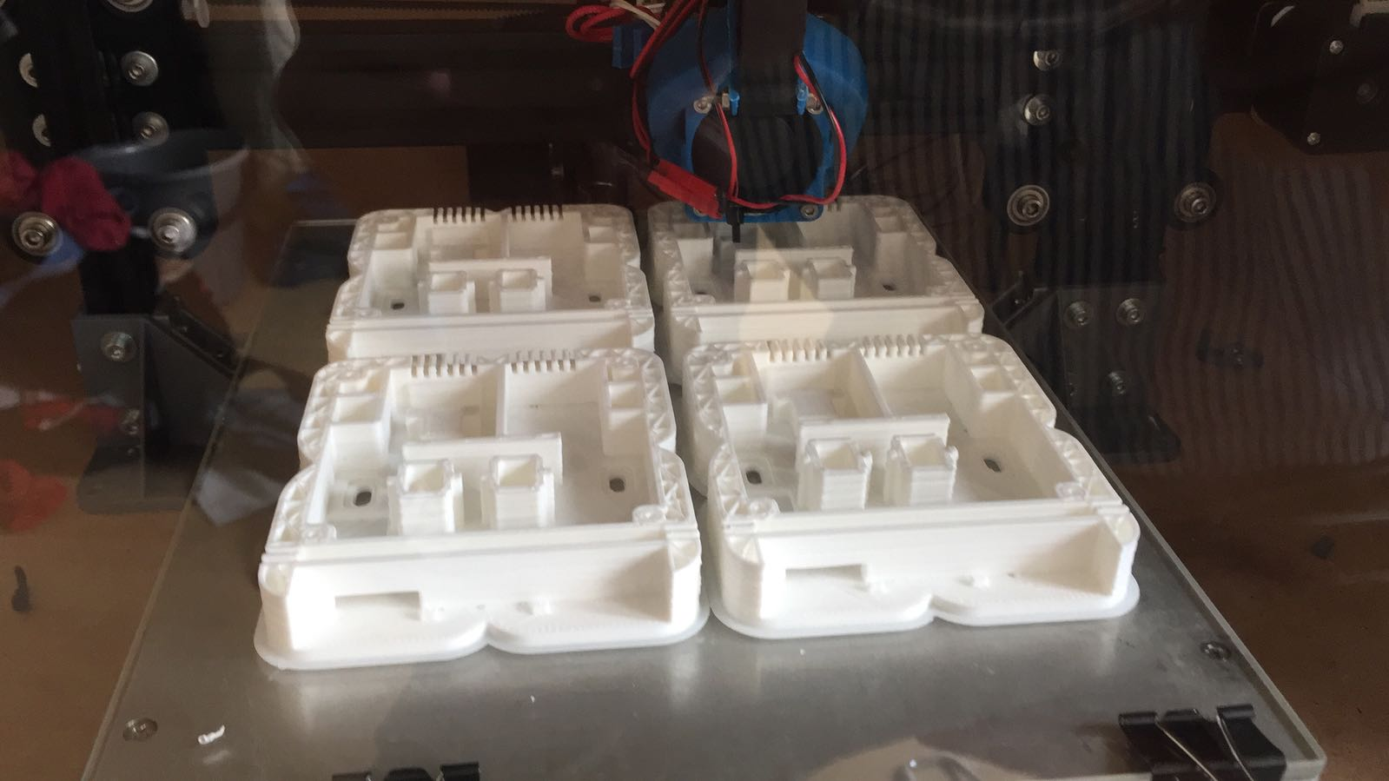

Mass production of the units!

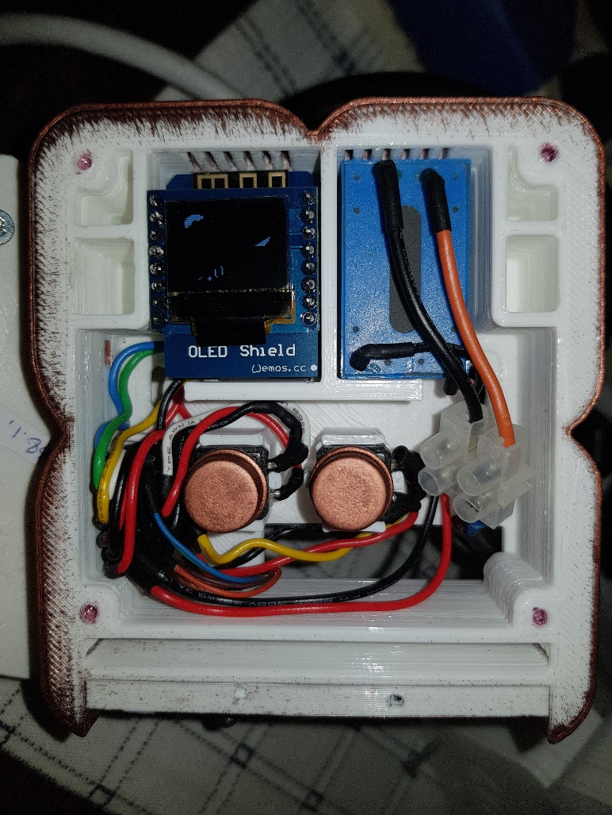

The unit assembled (note that I painted this one which is the copper residue you see on the edges).

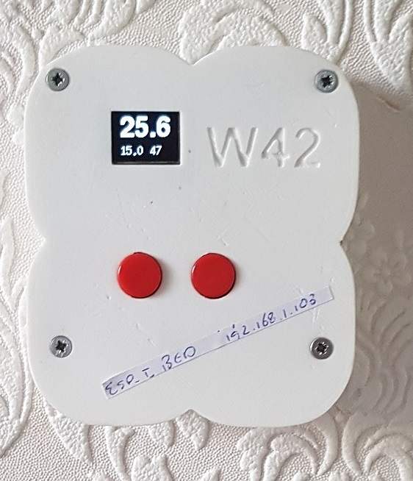

The first unit in 'production'. This one has more curvy edges, I only made one of those, the rest are more shaped like the one below. What you see on the OLED is: current temperature (25.6C), target temperature (15.0C) and the humidity (47%). The latter (humidity) is replaced with H and or M when the heat is requested or a maintenance cycle is active.

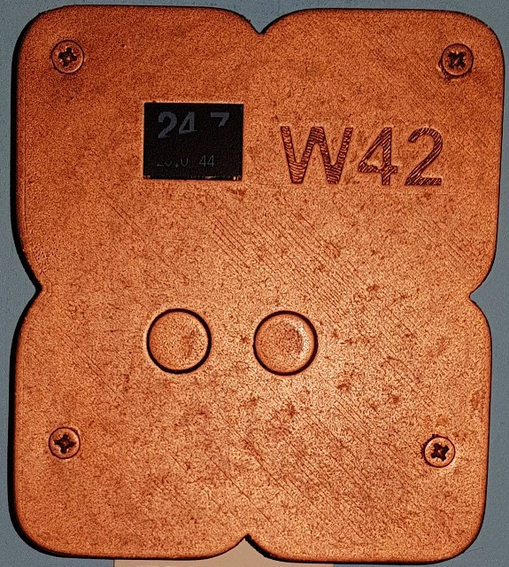

One unit painted copper, for in the room of one of our kids.

**Wrapping it up part II (The relays)**

For the relay we need something similar, fortunately this is really simple. I recall that I created the file for print in less than an hour, so perhaps I should not provide the file as it’s a good exercise :D.

Just kidding, here are two links, this one is to the 2 channel relay box: <https://a360.co/2ujw7jk>

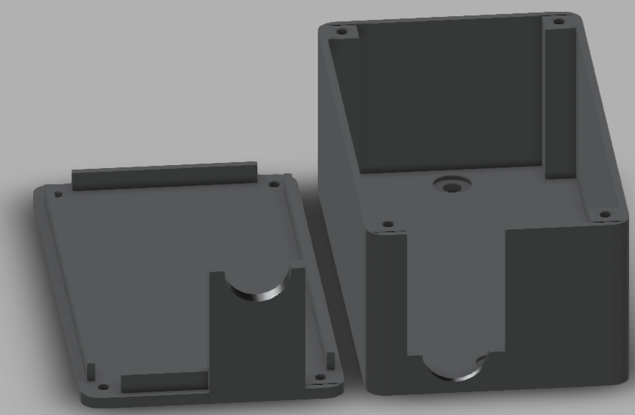

and this one is a bigger version for the 4 channel relay, which requires a bit more space: <https://a360.co/2L4oFQu>

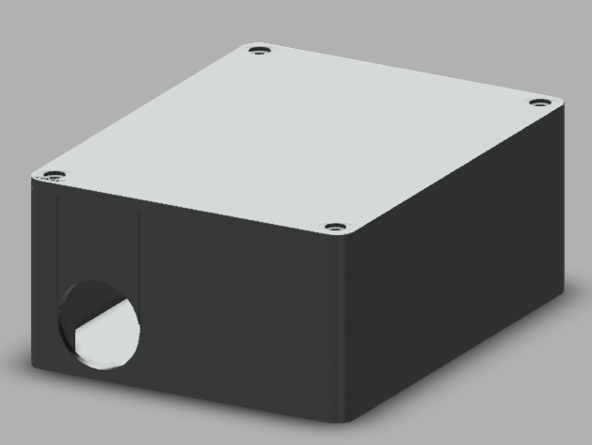

**Really wrapping it up? (or is there more)**

Yes there's more. The project is now running on and off for about 3 months and there are still a couple of things I want to add: a monitoring unit and additional sensors.

**The monitoring unit** needs to check whether a Wemos device goes off line for a longer period of time (> 10min.) in which case its unlikely that it will *ever* connect! I've seen this happen occasionally and I've been able to improve the communication protocol and haven't seen the issue since…however I'm not going to check this constantly so should this happen then I need to reset the router. The Wemos device will constantly try to reconnect, so that’s not the problem, the reason it cannot connect anymore is because the DHCP address on the router has not been properly released (e.g. a wemos on DHCP 192.168.1.50 tries to reconnect on that address, but the router still thinks 'something' is connected on that address. The only way to solve that issue is by resetting the router. So the task of the monitor is to do exactly that.

**The additional sensors** are waterproof DS18B20 temperature sensor which have the great feature that you can connect numerous of those to only 1 pin on the Wemos. What are they going to sense? The temperature of the tubes of the distribution unit AFTER the thermostatic actuator. This way I can monitor whether there is ACTUALLY warm water going into my floor.

Both however are as of yet not implemented. To be continued…